HHpro
User Guide

Mechanical schedules, submittals, documentation and HVAC calculators
https://hhpro-hvac.com
Revised October 2026
Contents
1. Getting Started 4
1.1 What HHpro is 4
1.2 Getting to the site 4
1.3 Your account 4
1.4 Signing in 5
1.5 Forgot password 5
1.6 The header 6
1.7 The overview page 6
2. Product Pages 8
2.1 The picture picker 8
2.2 Filtering 9
2.3 Reading the schedule 10
2.4 Dropdowns inside the schedule 10
2.5 Select, Submittal, Docs and Configure 12
2.6 Notes on individual products 13
2.7 GPS Bipolar Ionization 17
3. Projects and the Cart 19
3.1 Your first Select 19
3.2 The cart panel 21
3.3 The Projects page 21
3.4 Where your projects live 22
4. The Project View 23
4.1 Tabs 23
4.2 The toolbar 24
4.3 Schedule layout 24
4.4 Auto Tag 24
4.5 Arranging the rows 25
4.6 Add / Remove Columns 26
4.7 Edit Schedule 27
4.8 Schedule notes 27
4.9 Undo, Redo and leaving 28
4.10 Exporting the schedule 28
5. The Refrigerant Tab 29
6. The Calculations Tab 30
7. The Files Tab 31
7.1 Choosing what to download 31
7.2 Project Schedules 31
7.3 Downloading 32
8. Design Search 33
8.1 Running a search 33
8.2 Performance at design conditions 34
8.3 Daikin Light Commercial RTUs 35
9. Calculators 39
9.1 Common controls 39
9.2 Psychrometrics 39
9.3 Supply Air Dew Point 41
9.4 Ductulator 42
9.5 Saving calculations to a project 42
10. Finding a Model Number 43
11. Appendix 44
11.1 Privacy and your data 44
11.2 Quick reference 44
11.3 Things to watch for 45
11.4 Getting help 45

1. Getting Started

1.1 What HHpro is
HHpro is Hoffman & Hoffman's equipment site for mechanical engineers. It holds pre-engineered mechanical schedules for the HVAC equipment we sell, the documentation that goes with them, and a set of HVAC calculators. From one browser tab you can:
- Filter a product line down to the units that fit your application.
- Search by design load instead of by model number.
- Collect complete systems into a named project, saved to your HHpro account.
- Tag the units, choose which columns appear, edit any value, and add schedule notes.
- Export the finished schedule as Excel, CAD (DXF) or PDF, ready to drop into a drawing set.
- Download submittals, engineering, installation and operation manuals, Revit families and CAD files as a single ZIP.
- Work out refrigerant line-set lengths and charge for split systems.
- Run psychrometric, supply air dew point and duct sizing calculations, and keep them with the project.

1.2 Getting to the site
- Address: https://hhpro-hvac.com
- Nothing to install and no VPN; any network with internet access will do. Your projects are saved to the Hoffman & Hoffman server as you work, so you need to be online to use the site.
Browser: Use a current version of Chrome or Edge on a desktop-sized window. The schedules are wide. They scroll sideways on a small screen and are not practical on a phone.

1.3 Your account
Everyone has their own HHpro account, set up by an administrator. What you see follows your account: the product lines shown depend on your office location(s), and the schedule layouts you can choose depend on your company (section 4.3).
Setting your password. When your account is created you receive an invitation email with a registration link.
1. Open the link. The page shows your name and email address.
2. Choose a password of at least 10 characters (a short phrase works well) and type it twice.
3. Click Set password and sign in. You land on the overview page, already signed in.
A registration link works once and expires after 72 hours. If it has expired or "can't be used", ask your administrator to send a new one.

1.4 Signing in
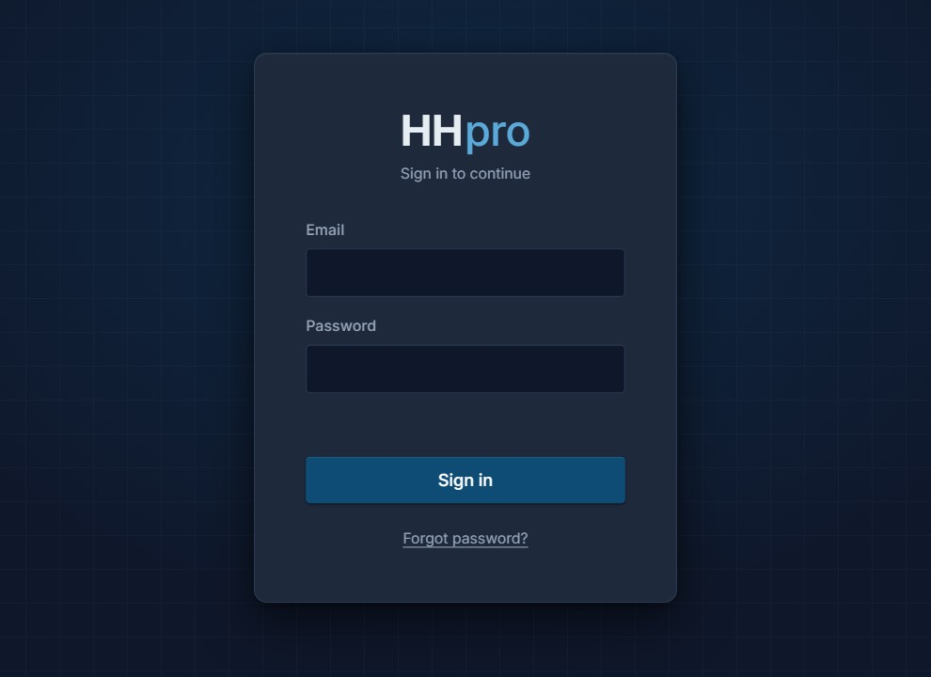
The sign-in page.
Enter your Email and Password and click Sign in.
- You stay signed in on that browser until you click Log out. Closing the browser does not sign you out. A different computer or browser asks you to sign in once.
- After 10 wrong passwords, sign-in is paused for 15 minutes.
- "Your account is waiting for you to set a password" means the registration link has not been used yet. Check your email, or ask your administrator to resend it.
- The Privacy & Data link in the bottom corner can be read before you sign in.

1.5 Forgot password

Forgot password opens a message in your own mail program.
HHpro never sends email itself. Click Forgot password?, enter your email address and click Open email. HHpro opens a pre-written message in your own mail program, addressed to the person who set up your account, asking for a reset link. Send it; they reply with a link to choose a new password, which works just like the registration link. Back to sign in returns to the sign-in form.
If there is no account for the address you entered, the page tells you who to email to get set up.

1.6 The header
The header: logo and breadcrumb, the model search box, User Guide and Log out.
The blue bar at the top of every page holds the controls that are always available.
- HHpro logo (left): click it to return to the overview. Inside a product, project or calculator, the page name appears beside it as a breadcrumb.
- Find a model number (center): searches the products your account can see and jumps straight to a model. See section 10.
- User Guide: opens this guide in a new tab.
- Users: shown to administrators only, and covered in its own guide.
- Log out: signs you out on this browser. Hover over it to see whose account is signed in. Your projects stay in your account.
The browser's Back and Forward buttons move between HHpro's own pages.

1.7 The overview page
After signing in you land on the overview. Everything in the site starts from one of these tiles.
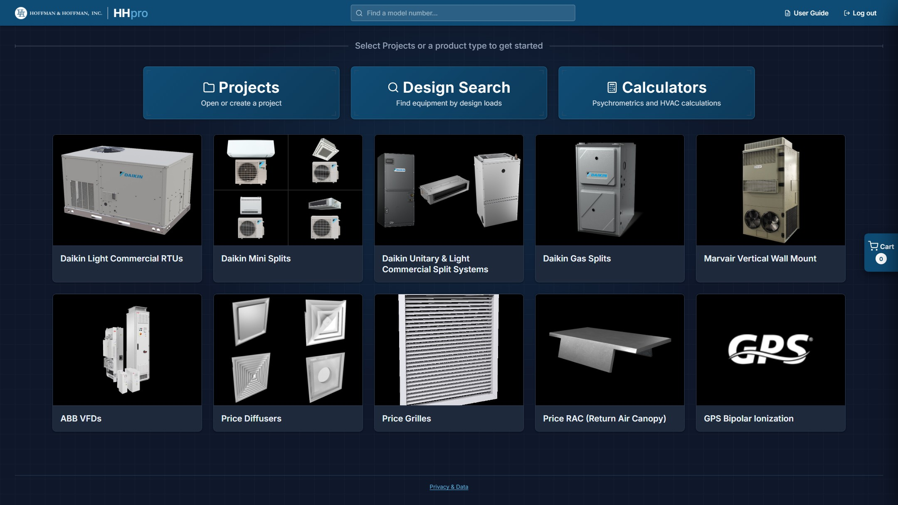
The overview: Projects, Design Search and Calculators on top, one tile per product line below.
- Projects: open a saved project or start a new one (section 3.3).
- Design Search: find equipment by entering design loads rather than by browsing (section 8).
- Calculators: psychrometrics, supply air dew point and duct sizing (section 9).
- Product tiles: open a product's schedule to browse and select equipment (section 2). The ten product lines are Daikin Light Commercial RTUs, Daikin Mini Splits, Daikin Unitary & Light Commercial Split Systems, Daikin Gas Splits, Marvair Vertical Wall Mount, ABB VFDs, Price Diffusers, Price Grilles, Price RAC (Return Air Canopy) and GPS Bipolar Ionization. Product lines that are not offered at your office location(s) are not shown.
The Cart tab on the right edge is always visible. It shows what you have collected so far and gets you into the project view in one click (section 3.2).
Calculators-only accounts: Some accounts, such as a manufacturer reviewing the tools, see only the Calculators tile. Products, Projects, Design Search, the model search box and the cart are not available to them, and calculations can be exported to PDF but not saved to a project.

2. Product Pages
Every product tile opens the same kind of page: an optional picture picker at the top, a row of filter dropdowns, and the schedule itself. (GPS Bipolar Ionization works a little differently; see section 2.7.) Each row of the schedule is a complete, pre-engineered selection with capacities, airflow, electrical data and weights already filled in. Back to Products (top right) returns to the overview.
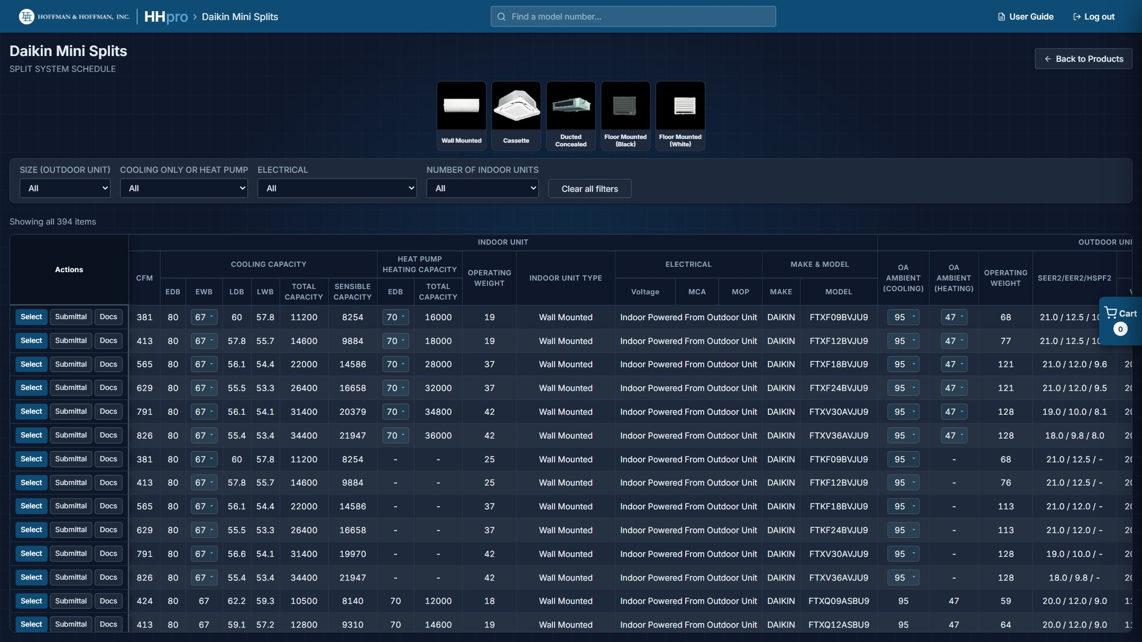
A product page: picture picker, filter bar, and the schedule below.

2.1 The picture picker
Daikin Mini Splits, Daikin Unitary & Light Commercial Split Systems, Price Diffusers and Price Grilles open with a strip of pictures above the filters. Clicking a picture filters the schedule to that style, which is usually the quickest way to cut a long list down. Click the same picture again to release it.
- Mini Splits: indoor unit style (Wall Mounted, Cassette, Ducted Concealed, Floor Mounted (Black) and Floor Mounted (White)). The picture filters on the first indoor unit of the system.
- Unitary & Light Commercial Split Systems: air handler style (Multi Position (1.5 to 10.0 Tons), Ceiling Mounted (1.5 to 2.5 Tons) and Apartment Style (1.0 to 3.0 Tons)). The style has no dropdown of its own; when the other filters leave only one style, its picture lights up.
- Diffusers: model family (SPD, SCD, SPD (Return), SCDA, SMD/AMD, SMD w/ SR and PDDR).
- Grilles: family (150, 20/30, 300, 500/600/700, 900 GYM, 540/640, LINEAR BAR, LINEAR BAR HD, 500/600/700 RTN, 60/70, EGG CRATE, PERFORATED, 90 GYM RTN, LATTICE and TRANSFER).
When an SMD-family diffuser is picked, a Core style row of icons appears. Each icon is a filter button for that core style; dimmed icons are shown for reference but are not in the data.
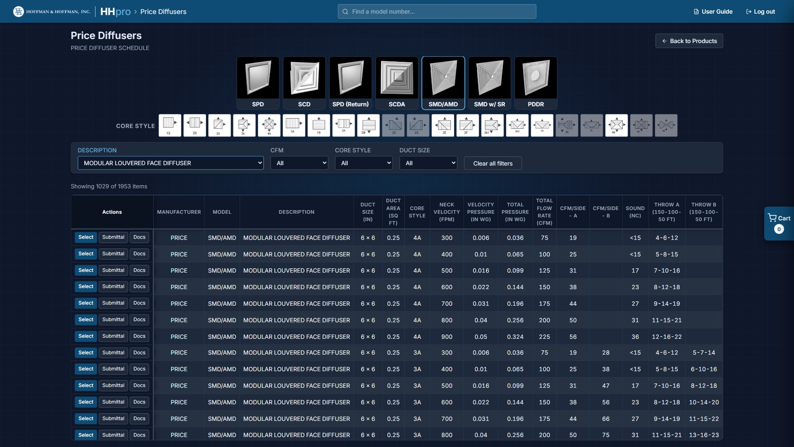
Price Diffusers with SMD/AMD picked: the family pictures, the core style icons, then the filters.

2.2 Filtering
The filter bar sits above the schedule. Set the dropdowns left to right and the list narrows as you go; the dropdowns are linked, so each one only offers values that are still achievable given the others.
The filter bar. A dropdown that is doing work is highlighted; Clear all filters resets them.
- If a filter is left with only one possible value, the site picks it for you. Change any dropdown yourself and the automatic picks re-evaluate.
- Some filters only appear once they are relevant. On Mini Splits, for example, the indoor unit size and type filters appear after you set the number of indoor units.
- Clear all filters puts the page back to the full list.
The status line under the filters always tells you where you stand, for example "Showing 2 of 394 items". On Light Commercial RTUs, Unitary & Light Commercial Split Systems and Marvair the count includes every heat size or electric heat option, so it can be larger than the number of rows drawn.
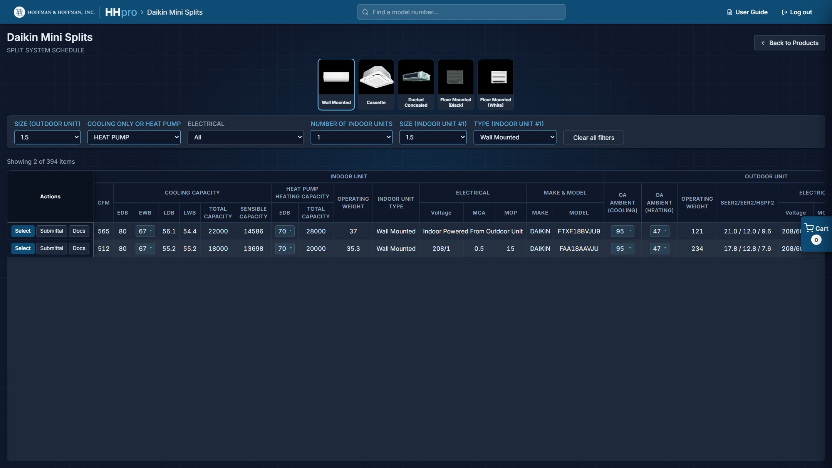
Daikin Mini Splits filtered to 1.5-ton, single-zone, wall-mounted heat pumps.
Grilles: The grille schedule holds over 32,000 selections, so the page only draws the first 500 that match. A notice tells you when that cap is in effect. Narrow the filters (or pick a family from the pictures) and it goes away.

2.3 Reading the schedule
Columns vary by product, but the layout is consistent. Grouped headers (INDOOR UNIT, OUTDOOR UNIT, COOLING CAPACITY, ELECTRICAL and so on) sit above the individual data columns, and the Actions column is pinned to the left.
One selection, several rows: A Mini Split selection covers the outdoor unit and every indoor unit on it, so one selection can occupy up to five rows. The Actions buttons appear once, on the first row of the group; clicking Select takes the whole system, not just the row you clicked.
Schedules are wider than most screens. Scroll the table sideways to reach the columns on the right; the header rows stay put as you scroll down.

2.4 Dropdowns inside the schedule
Some cells are dropdowns rather than fixed numbers. Changing one re-reads the manufacturer's published tables and updates every value that depends on it, so the row always shows performance at the condition you actually selected.
- Daikin Light Commercial RTUs: gas units show one row per cabinet, with the gas heat size in the Input (MBH) dropdown (for example "70 (Low)", "115 (Medium)", "140 (High)"). Changing it swaps in that unit's model number, airflow, cooling values, heating output and LAT. Heat pumps carry an Aux. Electric Heat kW dropdown that updates Unit MCA and MOCP.
- Daikin Mini Splits: single-zone and Sky Air systems with published tables offer the entering wet bulb (EWB), outdoor ambient for cooling and for heating, and the heating entering dry bulb. Leaving-air temperatures and total, sensible and heating capacity follow.
- Daikin Unitary & Light Commercial Split Systems: airflow (CFM), entering air dry bulb and wet bulb, outdoor ambient for cooling and for heat pump heating, and auxiliary electric heat kW. Total, sensible and leaving-air temperatures follow the cooling dropdowns; temperature rise, MCA and MOP follow the kW.
- Marvair: electric heat kW, which swaps MCA and MOCP to the values for that kW.
Rows without a published table show fixed values. The dropdowns only offer combinations that exist in the tables, so you cannot build an invalid selection. Whatever is showing when you click Select is what gets carried into your project and out to the exports, and the dropdowns stay live in the project view.
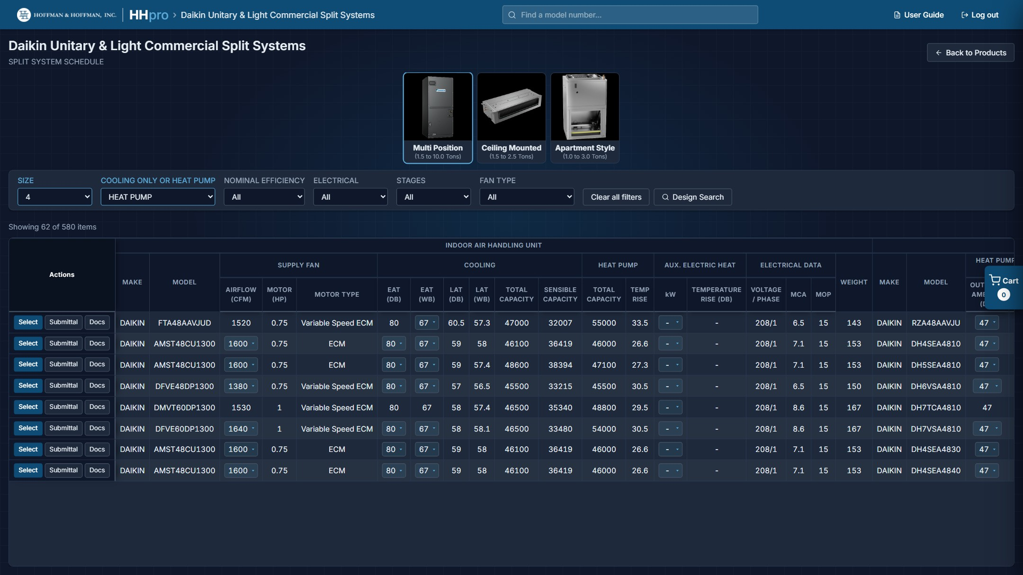
Daikin Unitary & Light Commercial Split Systems at 4 tons, heat pump: the Multi Position picture is lit, and the airflow, entering air and kW dropdowns feed the capacity columns.
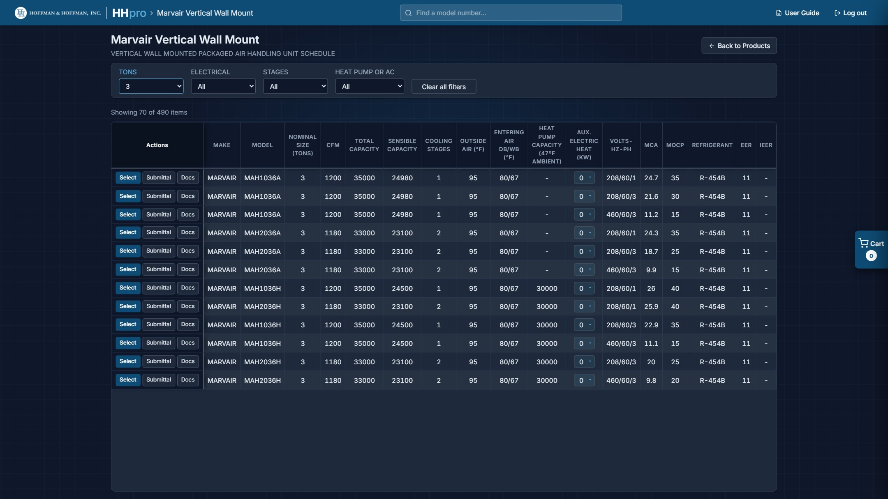
The Marvair schedule, with the electric heat kW dropdown in each row.

2.5 Select, Submittal, Docs and Configure
Every row carries three buttons in the Actions column; Daikin Light Commercial RTU rows have a fourth, Configure.
- Select: adds that unit (or complete system) to your project or cart. The first Select asks where it should go; see section 3.1.
- Submittal: opens the submittal PDF for that selection in a new tab. A split system opens the outdoor unit sheet plus one sheet per distinct indoor unit. When no submittal is published for a row, the button is struck through. A Light Commercial RTU row showing Design values (section 8.3) also opens its performance sheet.
- Docs: opens Available documents, every document published for that selection. PDFs have a View button; Revit and CAD files, which are ZIPs, have a Download button.
- Configure (Daikin Light Commercial RTUs only): opens that unit in Design Search, ready to change its motor, power exhaust, entering air and other options. See section 8.3. Rows on a project schedule have a Configure button too, which replaces the unit in place (section 4.5).
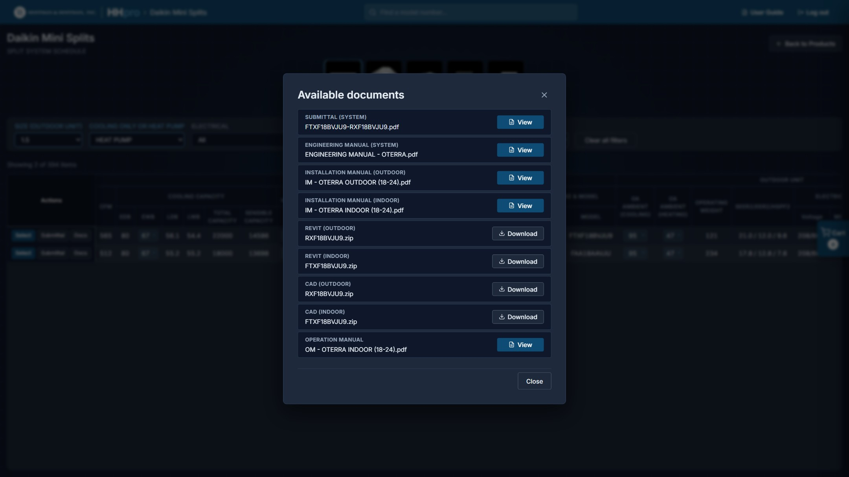
The Available documents popup lists everything published for the selection.
Pop-ups: Submittal and View open PDFs in new browser tabs. If nothing happens, allow pop-ups for hhpro-hvac.com.

2.6 Notes on individual products

Daikin Light Commercial RTUs
Packaged rooftop units, gas/electric units and heat pumps on one schedule. The filters are SIZE, ELECTRICAL, TYPE (GAS or HEAT PUMP), EFFICIENCY, COOLING STAGES, HIGH/MEDIUM/LOW GAS HEAT and HGRH (hot gas reheat). Heat pumps carry a Heat Pump Heating Performance column group (capacity at 47 °F and 17 °F, with COP); when only one type is in view, the other type's heating columns are hidden.
The schedule values come from selections run at one set of conditions (80/67 °F entering air, 95 °F ambient). If your conditions differ, use Design Search (section 8.3), which reads Daikin's published capacity tables instead. To start from a unit on this schedule, click its Configure button.
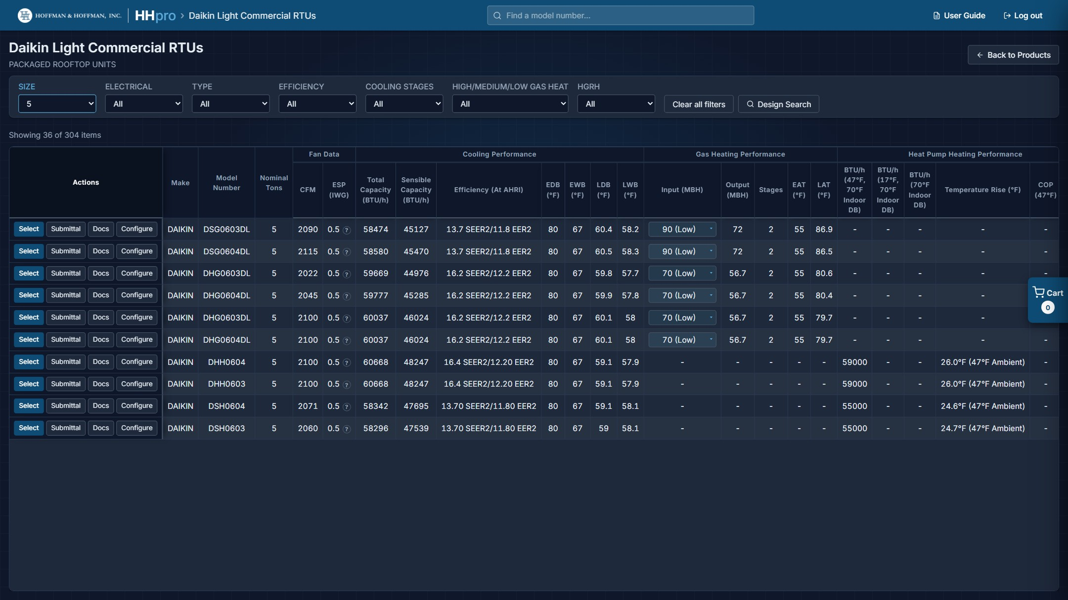
The Light Commercial RTU schedule filtered to 5 tons: gas units and heat pumps together, each with a Configure button.

Daikin Mini Splits and Unitary & Light Commercial Split Systems
Both are split systems, so both feed the Refrigerant tab (section 5) once they are in a project. Mini Split selections cover the outdoor unit and up to five indoor units; the number of indoor units is a filter of its own. Unitary & Light Commercial Split Systems pair an outdoor condensing unit with a multi position, ceiling mounted or apartment style air handler; pick the style from the pictures (section 2.1).

Daikin Gas Splits
Condensing unit, gas furnace and coil. The filter row carries the furnace side as well (GAS STAGES, GAS INPUT, GAS OUTPUT and AFUE (%)) alongside SIZE, NOMINAL EFFICIENCY, COMPRESSOR STAGES and COIL ORIENTATION. Gas Splits also appear on the Refrigerant tab.
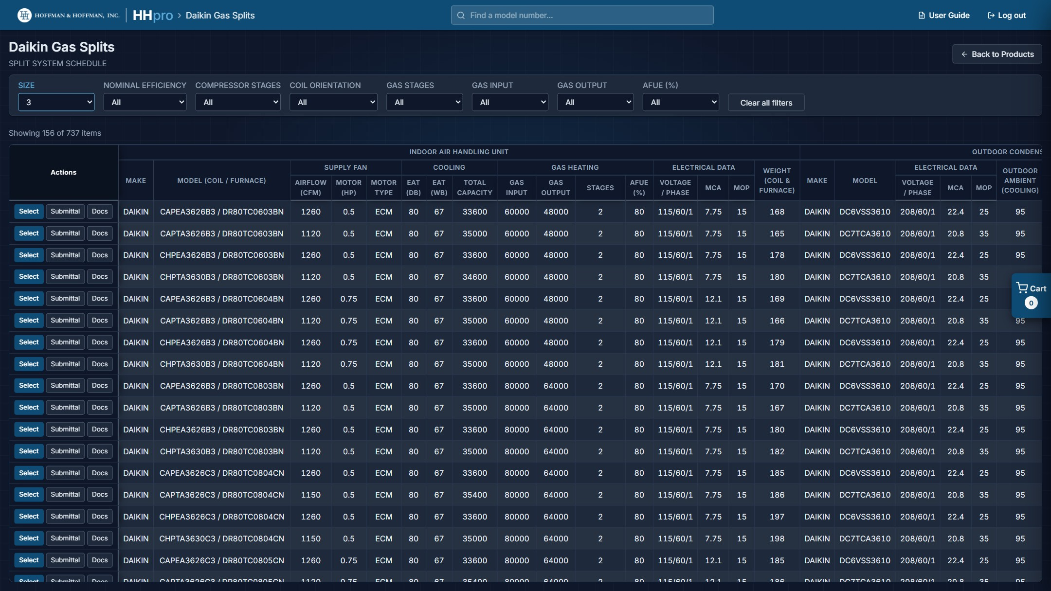
The Gas Split schedule. Furnace filters sit alongside the outdoor unit filters.

Marvair Vertical Wall Mount
Filtered by TONS, ELECTRICAL, STAGES and HEAT PUMP OR AC, with the electric heat kW dropdown described in section 2.4.

ABB VFDs
Filtered by HP, ELECTRICAL, ENCLOSURE, BYPASS and HARMONIC MITIGATION. VFD schedules work slightly differently from the equipment schedules: the notes are a fixed list you cannot edit, the schedule carries a per-item Notes column instead of an Accessories column, and the project schedule adds a Serves column you fill in yourself. Auto Tag defaults to the VFD- prefix.
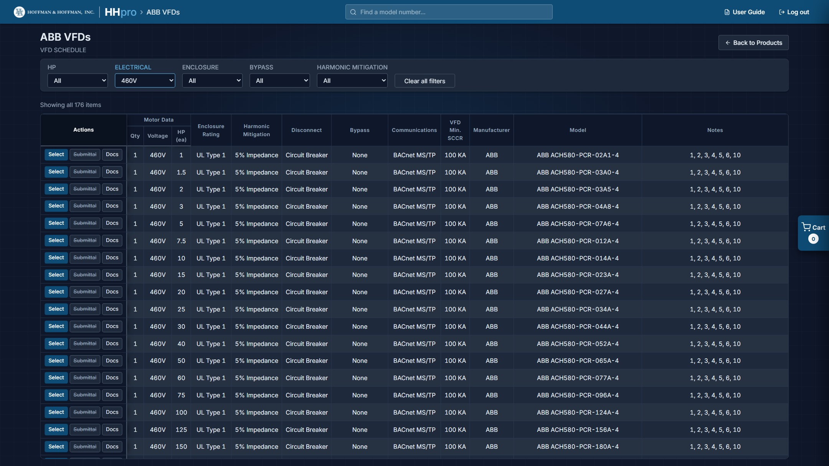
The ABB VFD schedule.

Price Diffusers and Price Grilles
These sheets hold many model families at once, so columns that do not apply to anything currently in view are hidden automatically. The schedule you see (and the one you export) only carries columns that have data. Auto Tag defaults to D- for diffusers and G- for grilles.
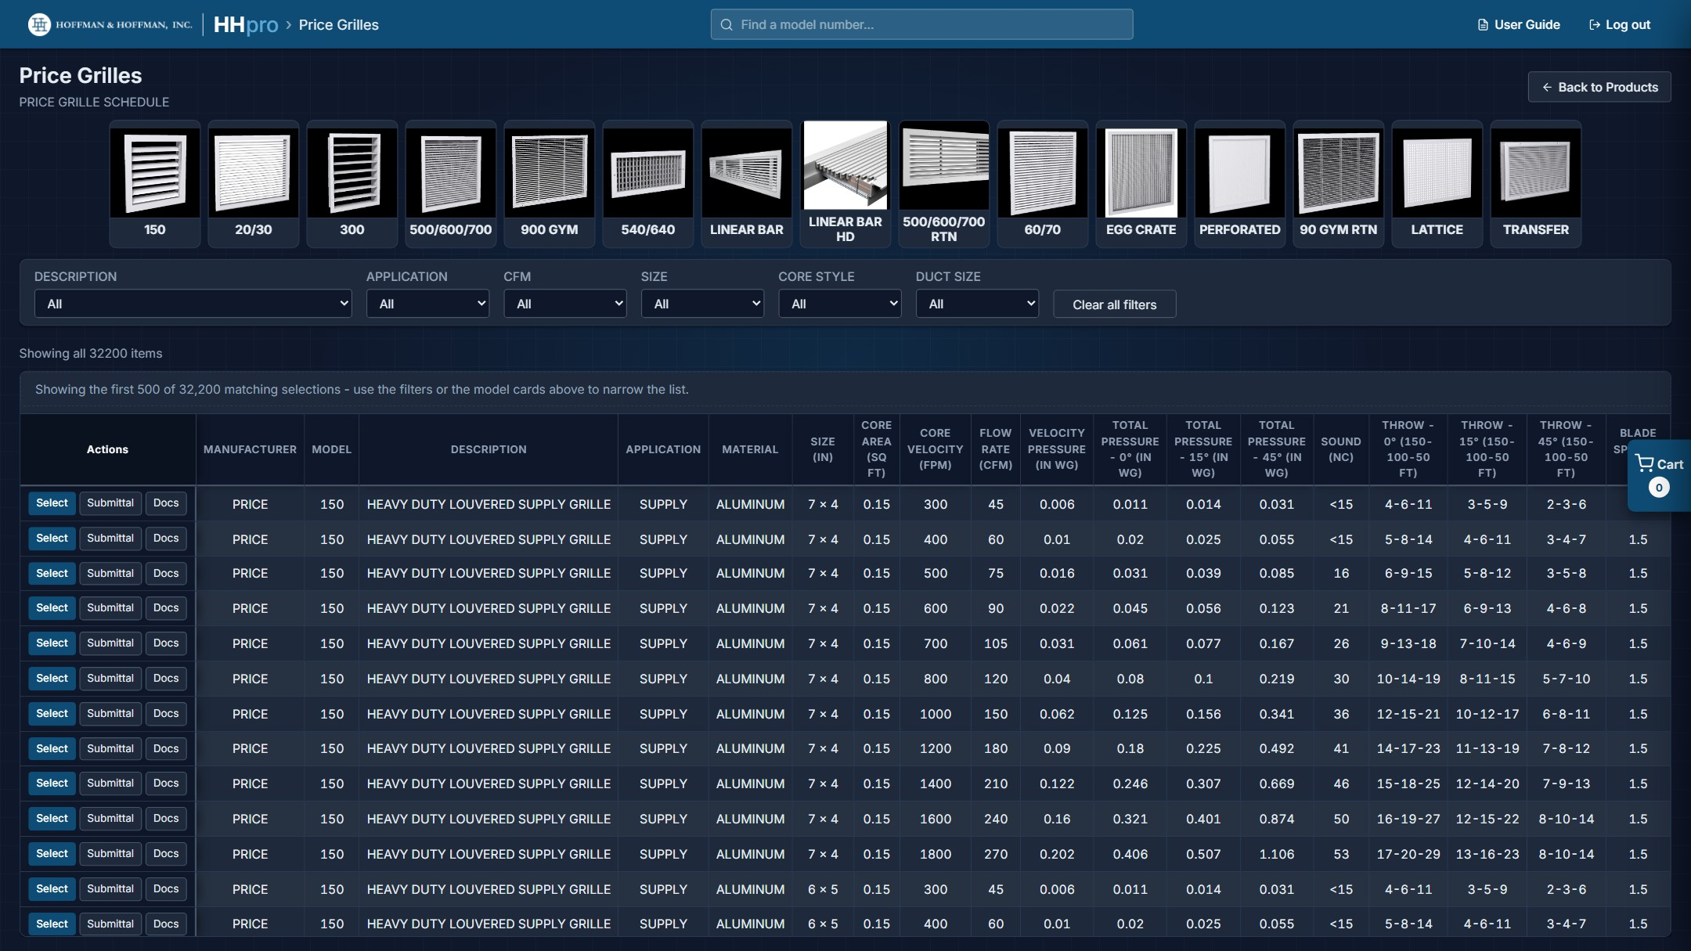
The Price Grilles schedule with the family pictures above it and the 500-row notice.

2.7 GPS Bipolar Ionization
The GPS tile opens on a gallery of seven product types: Ceiling Mounted Fan, Duct Mounted, Fan Coil Mounted, Fan Coil Mounted (BAS Compatible), Coil Mounted, Coil Mounted (Ductless or PTAC) and Pre-Filter. Click one to open its schedule; All Product Types goes back to the gallery.
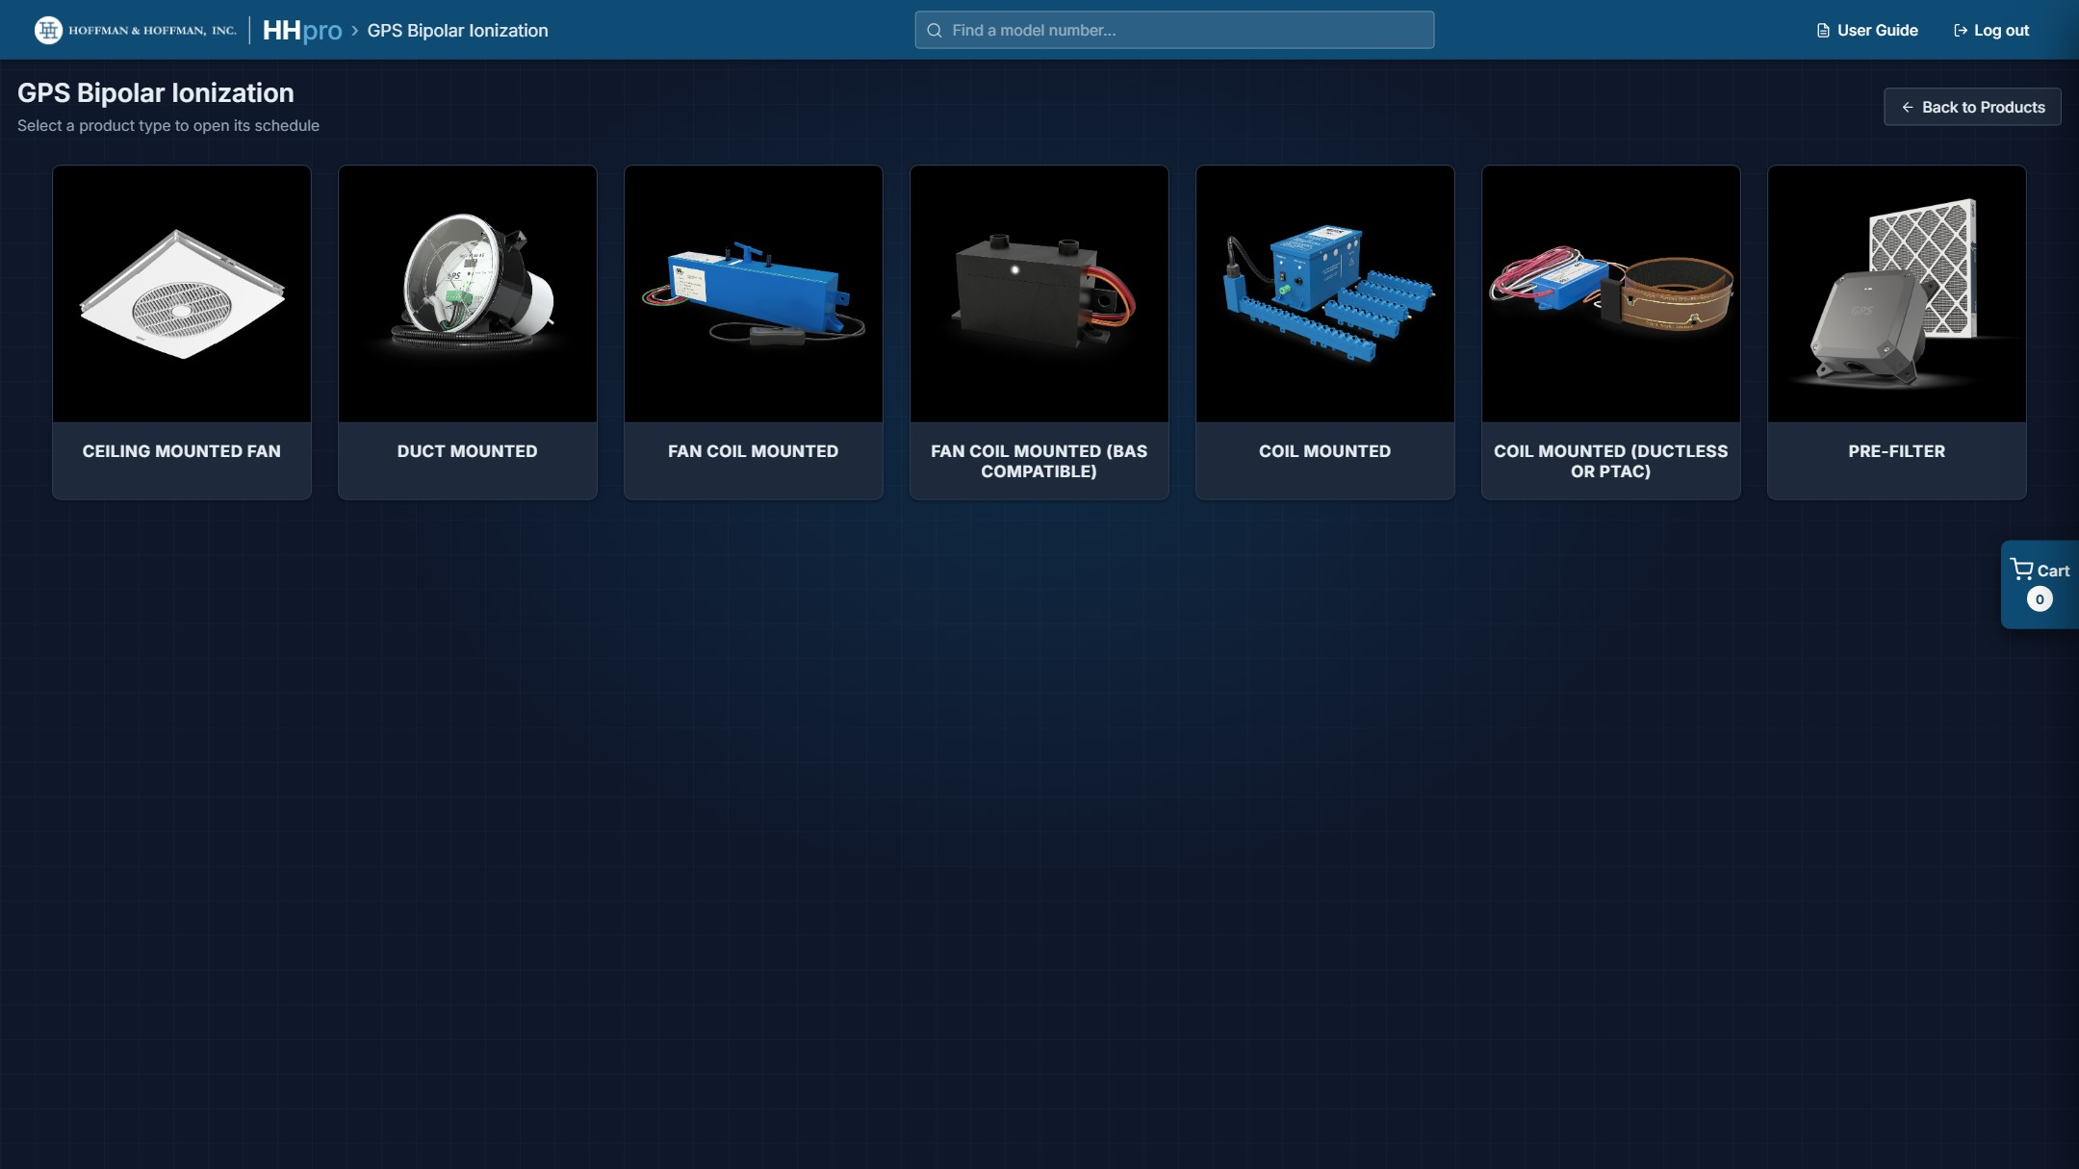
The GPS Bipolar Ionization gallery.
Each GPS schedule is short, so there is no filter bar. Select, Submittal and Docs work as they do elsewhere. The numbered notes that go with the schedule are shown under it on the page, and the NOTES column on each row lists which of them apply.
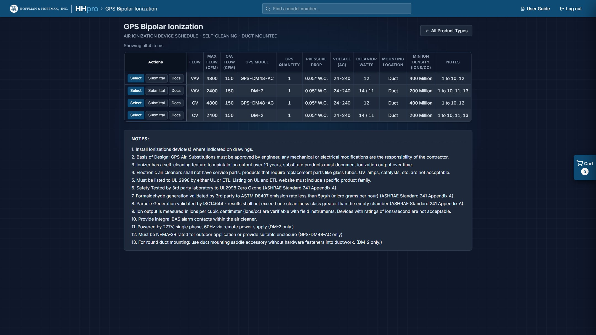
A GPS schedule (Duct Mounted) with its notes underneath.
In a project, GPS items are tagged AI- by default, the Accessories column starts as "All", and the notes are a fixed list. GPS is not part of Design Search.

3. Projects and the Cart

3.1 Your first Select
The first time you click Select, the site asks Where should this item go?
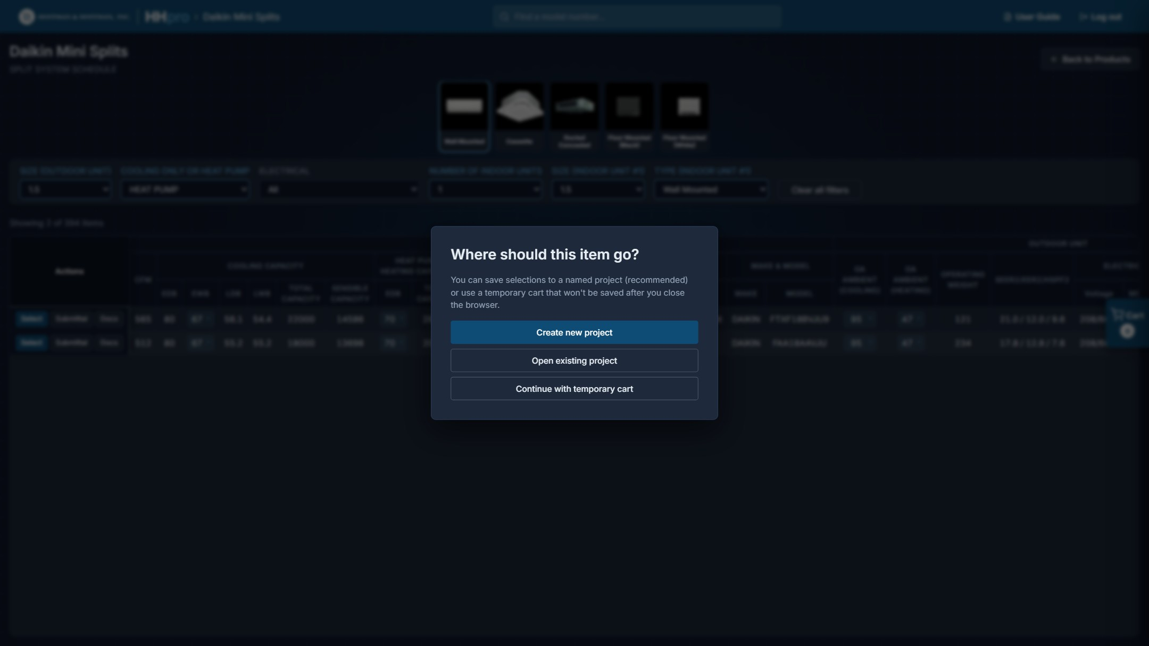
The first Select asks whether this is a project or a temporary cart.
- Create new project: recommended. Name it and it is saved to your account from then on; every later Select goes straight into it.
- Open existing project: add to a project you already started.
- Continue with temporary cart: a scratch list. It works like a project, but it is never saved. It is gone when you refresh the page, close the browser, sign out, or open a project.
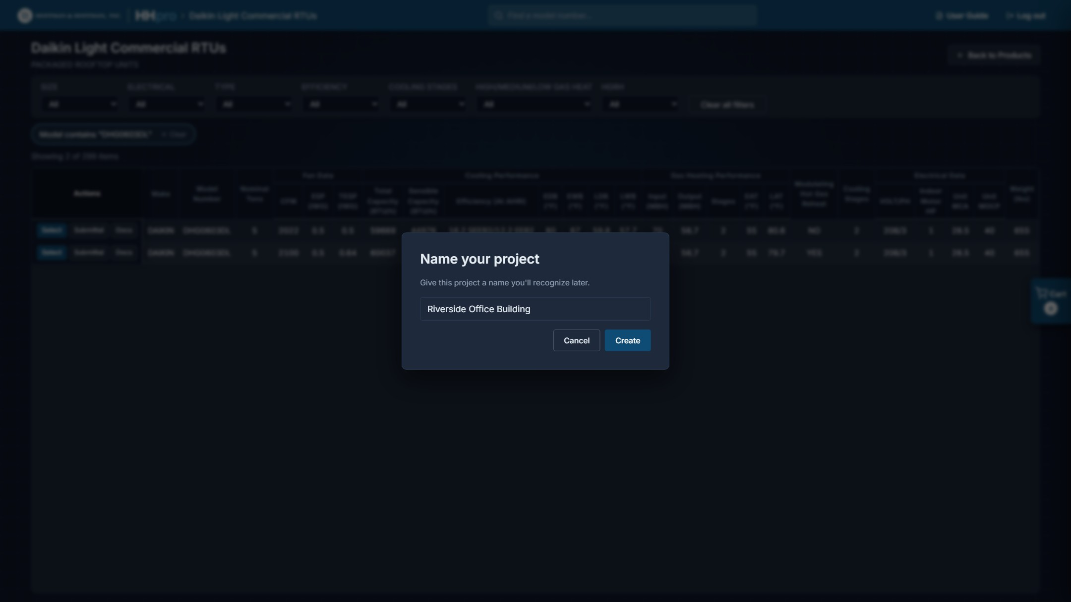
Naming a new project.
After that the prompt does not come back: Select simply adds to whatever is active, and the active project's name shows on the cart tab at the right edge of the screen. Refreshing the page closes the active project (nothing is lost), so the next Select asks again. Choose Open existing project, or use Continue on the Projects page.
Saving a calculation to a project (section 9.5) uses the same prompt.

3.2 The cart panel
Click the cart tab on the right edge to slide the panel open. It lists what you have collected, grouped by product type, with the size and model of each item.
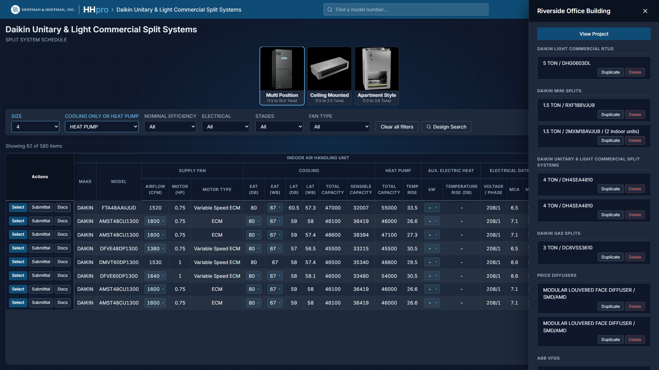
The cart panel, holding nine selections across six product types.
- Duplicate: adds a second copy of that item, for when the same unit appears several times on the job.
- Delete: removes it from the project.
- View Project: opens the full project view, where the schedule is built (section 4).

3.3 The Projects page
The Projects tile lists every project in your account with its item count and when it was last updated. The active project is badged ACTIVE.
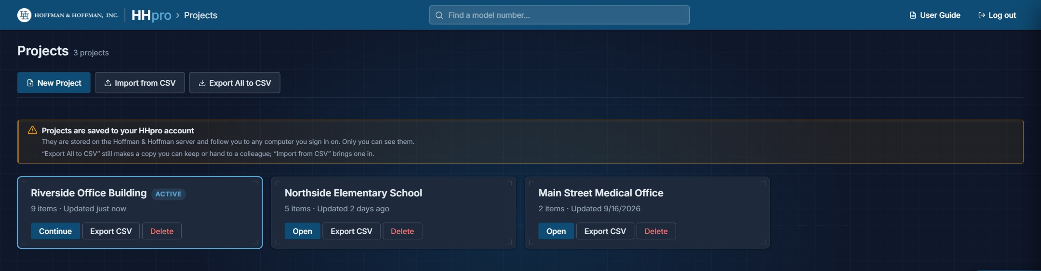
The Projects page.
- New Project: creates an empty project and makes it active.
- Open / Continue: makes that project active and opens its project view.
- Drag a project card to change the order. The order is saved to your account.
- Export CSV: saves that one project to a file.
- Export All to CSV: saves every project to a single file.
- Import from CSV: adds projects from a file to your account, whether it is your own copy or one a colleague sent you. If an imported project has the same name as one you already have, you can Replace existing or Rename imports.
- Delete: removes a project. You cannot undo this from the site.
Projects from before accounts: If you used HHpro before accounts existed, projects still saved in that browser are offered in a banner at the top of the Projects page. Move to my account copies them into your account; Leave them keeps them where they are.

3.4 Where your projects live
Projects are saved to your HHpro account on the Hoffman & Hoffman server as you work; there is no Save button. They follow you to any computer you sign in on, and only you can see them. The server also backs them up every night.
- If the server cannot be reached, HHpro keeps your changes on the page and keeps retrying, with the message "Can't reach the HHpro server to save. Keeping your changes here and retrying." When it reconnects you see "Back in touch with the server. Your projects are saved." Keep the tab open until then.
- Projects are not shared between accounts. To hand a project to a colleague, use Export CSV and have them Import from CSV.
Keep a copy: Export All to CSV makes a file you can keep outside HHpro. It is worth doing at project milestones, and before handing a project on.

4. The Project View
View Project is where a pile of selections becomes a mechanical schedule. Open it from the cart panel, or from Open / Continue on the Projects page.
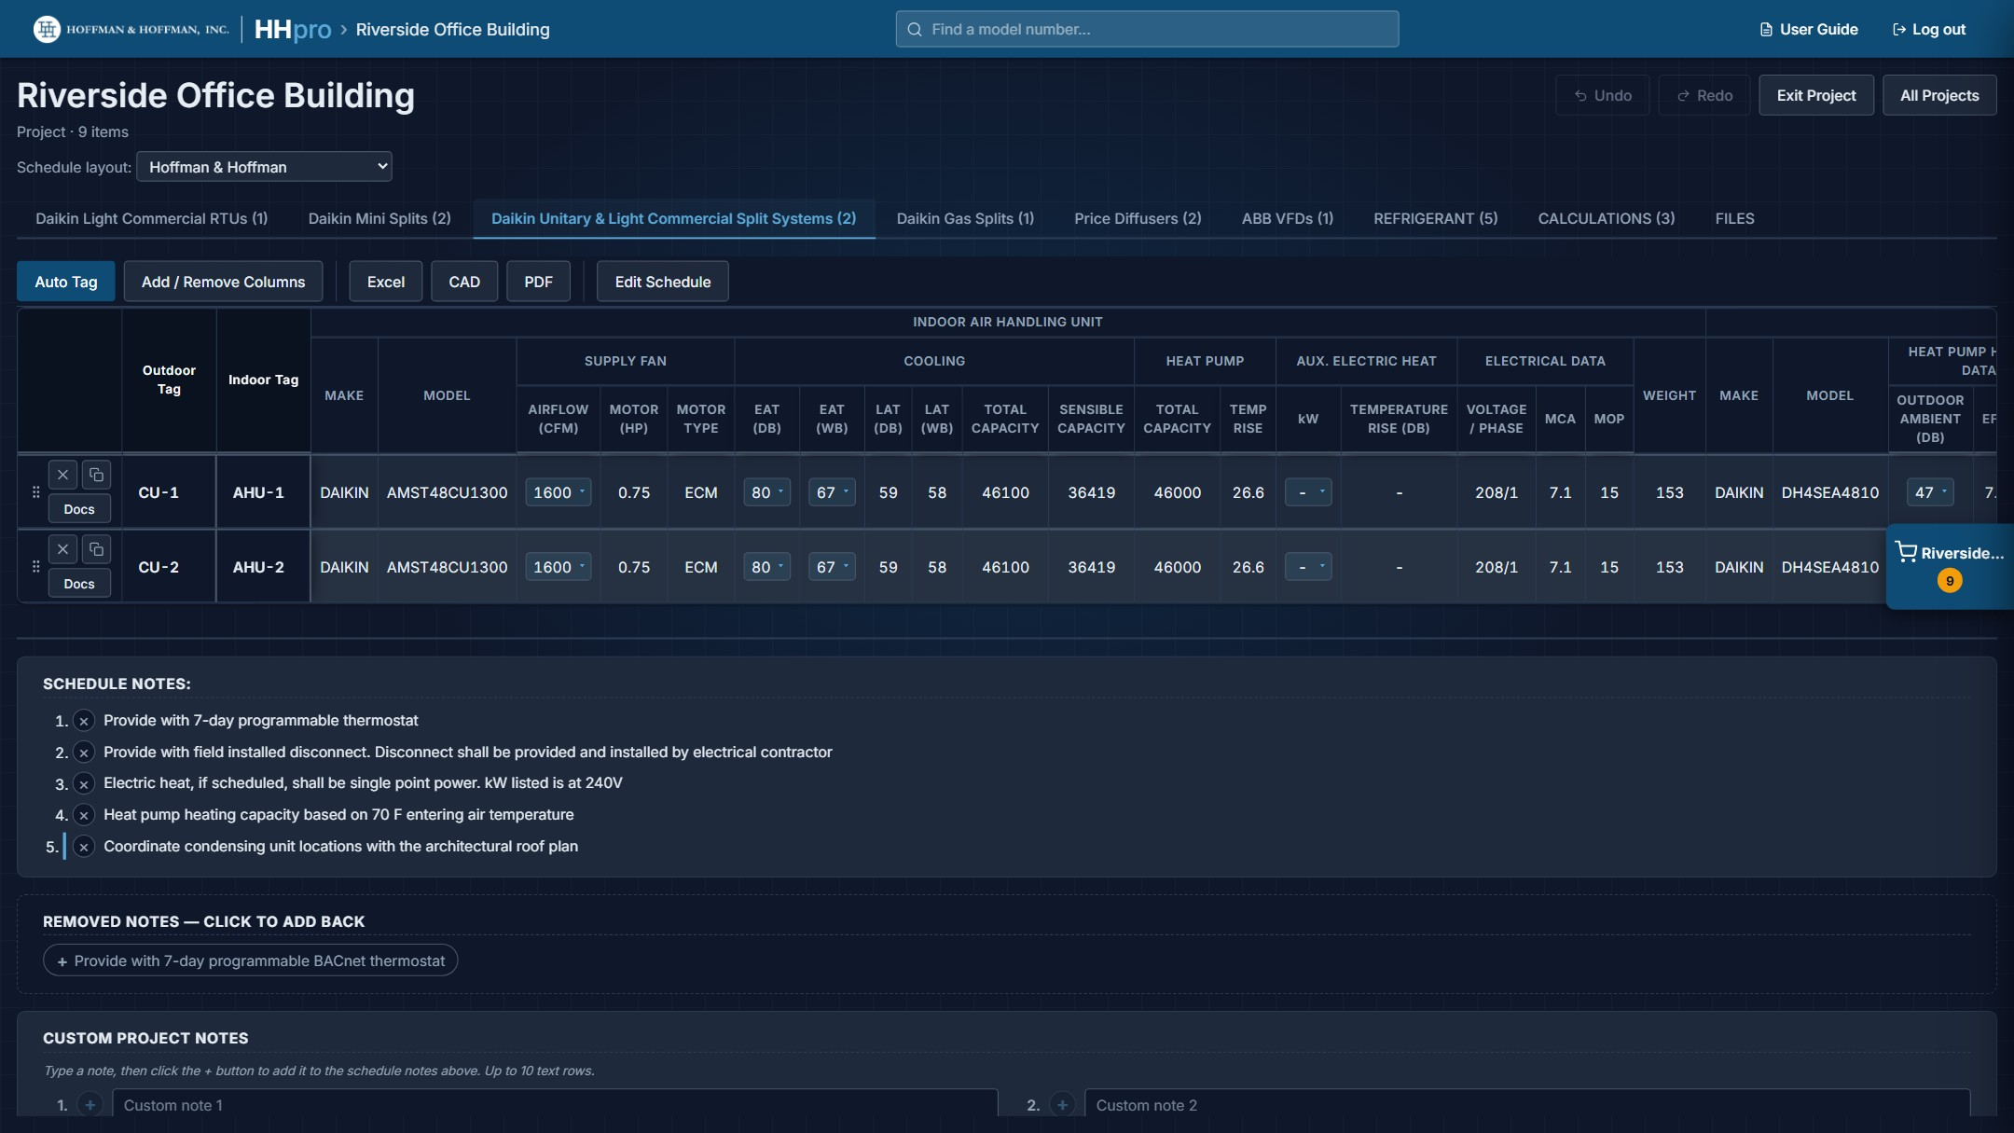
The project view: layout choice, tabs, toolbar, the schedule and the notes below it.

4.1 Tabs
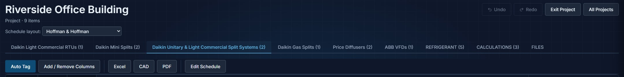
Schedule layout and Undo / Redo above the tabs; the toolbar below them.
The project gets one tab per product type you have selected from, each showing how many items it holds, plus these extra tabs:
- REFRIGERANT: appears when the project holds Mini Splits, Unitary & Light Commercial Split Systems or Gas Splits (section 5).
- CALCULATIONS: appears once calculations have been saved to the project (section 6).
- FILES: every document for everything in the project (section 7).
Product tabs are independent: tags, columns, notes and exports are all per tab. The Schedule layout is the one setting that applies to the whole project.

4.2 The toolbar
Auto Tag and Add / Remove Columns set the schedule up; Excel, CAD and PDF take it out of the site; Edit Schedule lets you change anything by hand.

4.3 Schedule layout
The Schedule layout dropdown above the tabs chooses whose schedule format the project uses. Hoffman & Hoffman is the standard layout and is always available. Some engineering firms have their own layout, with their columns, headings and notes. Which ones you can pick depends on your account: an engineer at one of those firms sees the standard layout plus their firm's, and new projects start on their firm's layout.
- A firm layout only changes the product tabs it covers. Other tabs stay on the standard layout.
- Under a firm layout the columns and notes follow that firm's format, so Add / Remove Columns and note editing are not available on those tabs.
- Firm layouts for Light Commercial RTUs cover gas units only. A single heat pump on the tab puts that tab back on the standard layout.
- Some firm layouts combine every split system into one read-only SPLIT SYSTEMS tab with continuous CU- / AHU- numbering.
- Hand edits (section 4.7) are kept separately for each layout.

4.4 Auto Tag
Auto Tag fills in equipment tags for every item on the tab, in the order they appear.
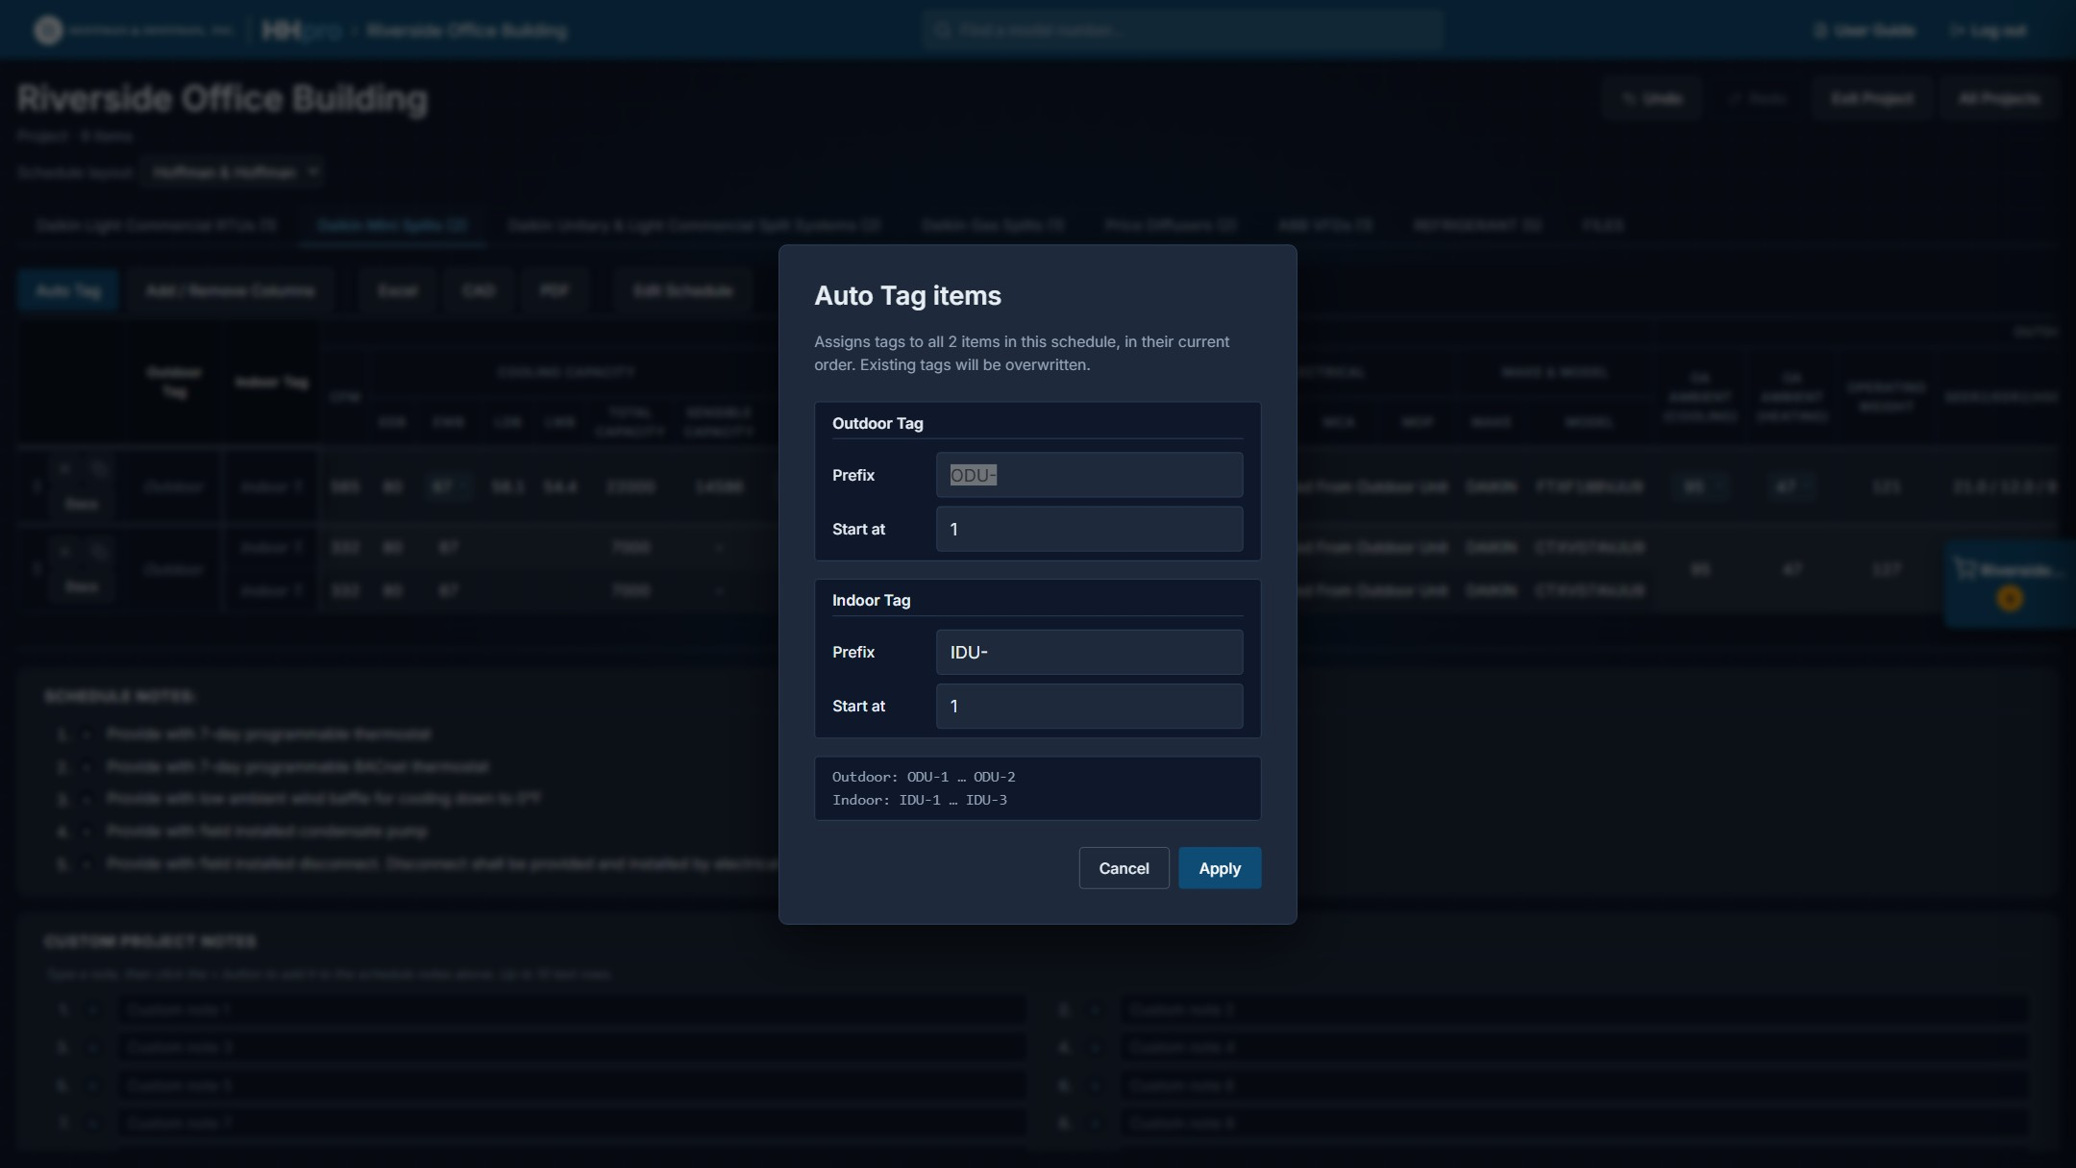
Auto Tag on a Mini Split tab: outdoor and indoor prefixes, start numbers and a preview.
- Set the prefix and the number to start at. The preview under the boxes shows the first and last tag.
- Split systems tag the outdoor and indoor units separately. Mini Splits default to ODU- and IDU-; Unitary & Light Commercial Split Systems and Gas Splits default to CU- and AHU-. The other defaults are RTU- (Light Commercial RTUs), AC- (Marvair), VFD-, D- (diffusers), G- (grilles) and AI- (GPS).
- Each tab is numbered on its own. If two tabs share a prefix (CU- on both Unitary & Light Commercial Split Systems and Gas Splits, say), start the second tab where the first leaves off so the tags don't repeat.
- Applying Auto Tag overwrites the tags already on the tab. Tags, and the Accessories column, can also be typed straight into their cells.
The prefix and start you used are remembered with the project, so the next run picks up where you left off.

4.5 Arranging the rows
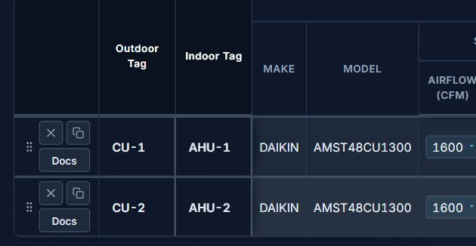
The row controls: drag handle, Remove, Duplicate and Docs.
Each row of a product schedule has its own controls on the left:
- Drag handle (the dotted grip): drag the row up or down to reorder the schedule.
- × (Remove from project): takes the item off the schedule and out of the project.
- Duplicate item: adds another copy of the item, with its tag left blank.
- Docs: the documents for that item.
- Configure (Daikin Light Commercial RTUs): opens the unit in Design Search, to change it and replace it on this row (below).

Replacing a Light Commercial RTU
Configure on a Light Commercial RTU row opens Design Search on that unit (section 8.3), with a banner naming it, and the Select button on every result reads Replace. Change the motor, power exhaust, heat kit, conditions or even the size, then click Replace on the result you want: the unit on this row is swapped for it and you come back to the project. The row keeps its tag, its place in the schedule and its accessories, and shows the new unit's design values. Don't replace in the banner turns Replace back into Select.
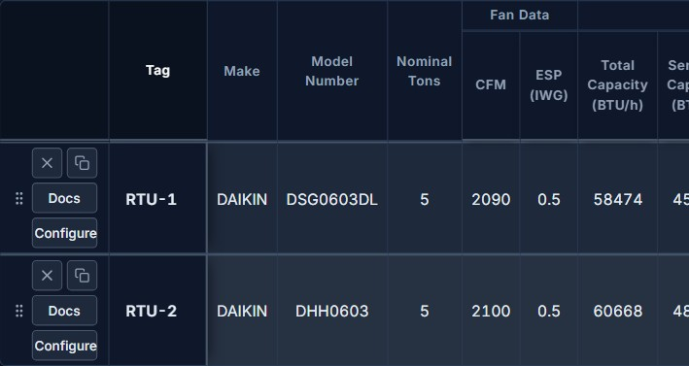
Light Commercial RTU rows add Configure under Docs.
Hand edits (section 4.7) on cells the new unit changes are cleared, because they were typed for the old unit, and a message says how many. Edits on other cells and other rows stay. Undo brings back the old unit and its edits in one step. The row controls, Configure included, are not shown under a firm layout (section 4.3).

4.6 Add / Remove Columns
Not every column belongs on every set of drawings. Add / Remove Columns opens Show / Hide columns, which lists every data column on the tab with a checkbox. Uncheck what you do not want and click Apply. Show all and Hide all are there for the extremes.
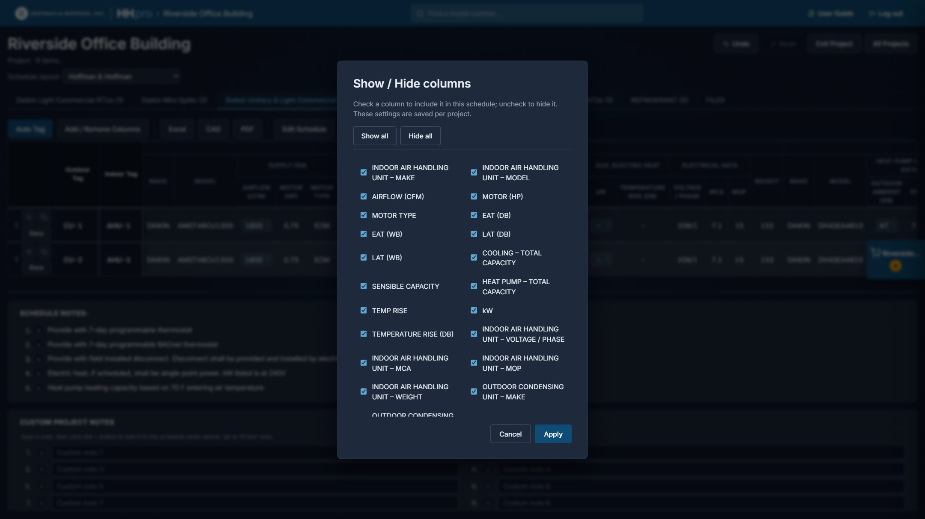
Choosing which columns appear on the finished schedule.
The choice is saved per project and per product tab, and it carries through to the Excel, CAD and PDF exports: what you see is what you get. Add / Remove Columns is available on the standard layout; it is not offered under a firm layout or on the GPS tab.

4.7 Edit Schedule
Edit Schedule turns every cell on the tab into a text box, so any value can be corrected or overwritten: tags, capacities, electrical data, accessories, anything. A change is saved when you leave the cell or press Enter, and it appears in the exports. Click Done Editing to leave the mode.
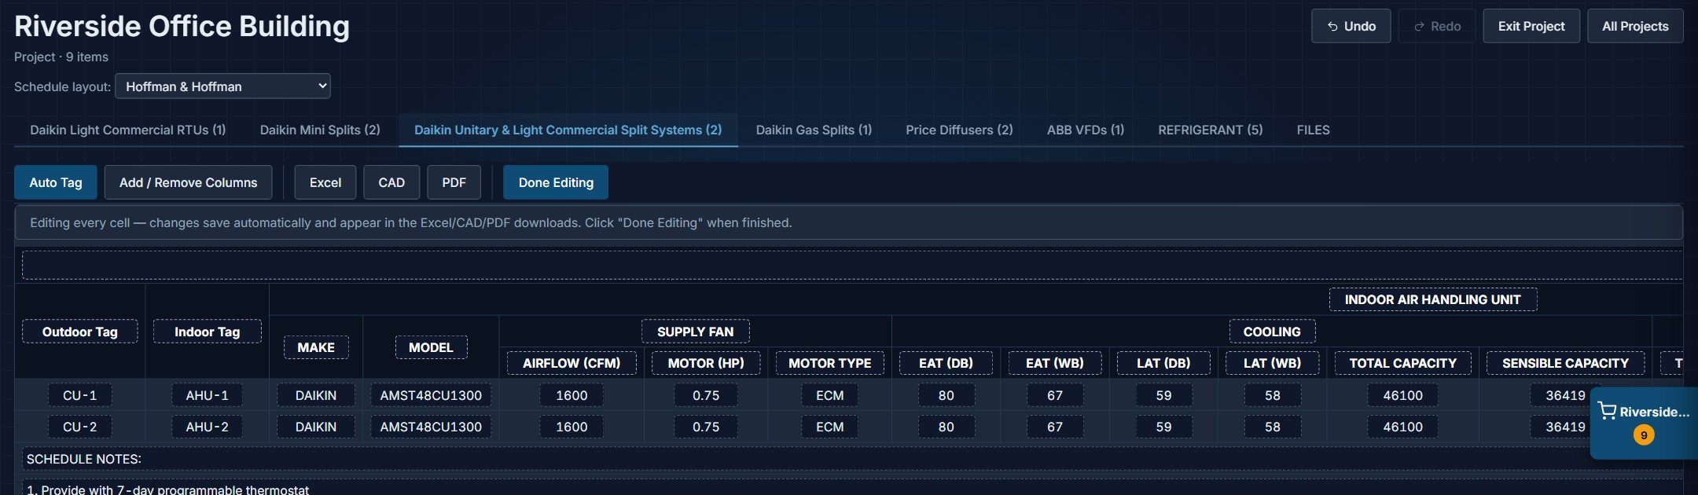
Edit mode: every cell becomes editable.
Edits stick: A value you type by hand stays as you typed it. If you later change a capacity dropdown, the hand-edited cell is not recalculated, so check it before exporting.
Edit last: Hand edits are tied to their position in the schedule. Finish adding, removing, reordering and duplicating units, and choosing columns, before you make hand edits. If you change the schedule afterwards, check the edited cells again. Replacing a Light Commercial RTU (section 4.5) clears the hand edits on cells the new unit changes.

4.8 Schedule notes
Below the schedule is the notes block that prints with it. Each product comes with a standard set of notes already filled in.
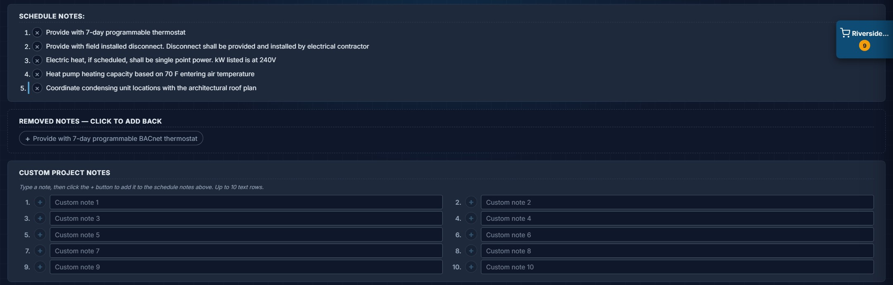
Schedule notes with one note removed and one custom note added.
- Remove a note that does not apply with the × beside it. Removed notes collect under Removed notes — click to add back. Click one to put it back.
- Add your own under Custom project notes: type the text in any box and click its +. The note joins the numbered list above and the box clears so it can be used again.
- Diffuser notes are matched to the models actually in the project, and an SMD/AMD core style legend is placed beside the notes when one of those models is present.
- VFD and GPS notes are a fixed list and cannot be edited. Under a firm layout the notes are that firm's.

4.9 Undo, Redo and leaving
- Undo / Redo (top right): step back through changes you have made in the project view, up to 50 steps. Ctrl+Z undoes; Ctrl+Shift+Z or Ctrl+Y redoes. The history starts fresh each time you open a project, and it does not cover the Schedule layout choice.
- Exit Project: closes the project without deleting it and returns to the overview. Reopen it any time from Projects.
- All Projects: back to the Projects page with the project still open. (With a temporary cart this button reads Back.)

4.10 Exporting the schedule
The three export buttons act on the tab you are looking at, using the layout, columns and edits you chose.
- Excel: downloads a formatted .xlsx workbook named after the project and the tab, with the merged headers, borders and schedule notes intact.
- CAD: downloads a .dxf. Under the schedule it adds an EQUIPMENT DRAWINGS block with front, right and top views of every unit on the tab, drawn at true size (1 drawing unit = 1 inch), with the overall width, height and depth called out and a scale bar for reference. A unit with no CAD geometry is left out of the drawings. The file opens in AutoCAD and in LibreCAD; column widths can be adjusted with Stretch.
- PDF: opens a clean print-ready window laid out for landscape letter and starts the print dialog. Choose Save as PDF (or send it straight to a printer).
To export everything at once instead of tab by tab, use the Project Schedules entries on the Files tab (section 7). Full Schedule.dxf draws every unit in the project.

5. The Refrigerant Tab
Any project holding Mini Splits, Unitary & Light Commercial Split Systems or Gas Splits gets a REFRIGERANT tab. It carries the factory data for each system and works out the charge from the line-set lengths you measured.
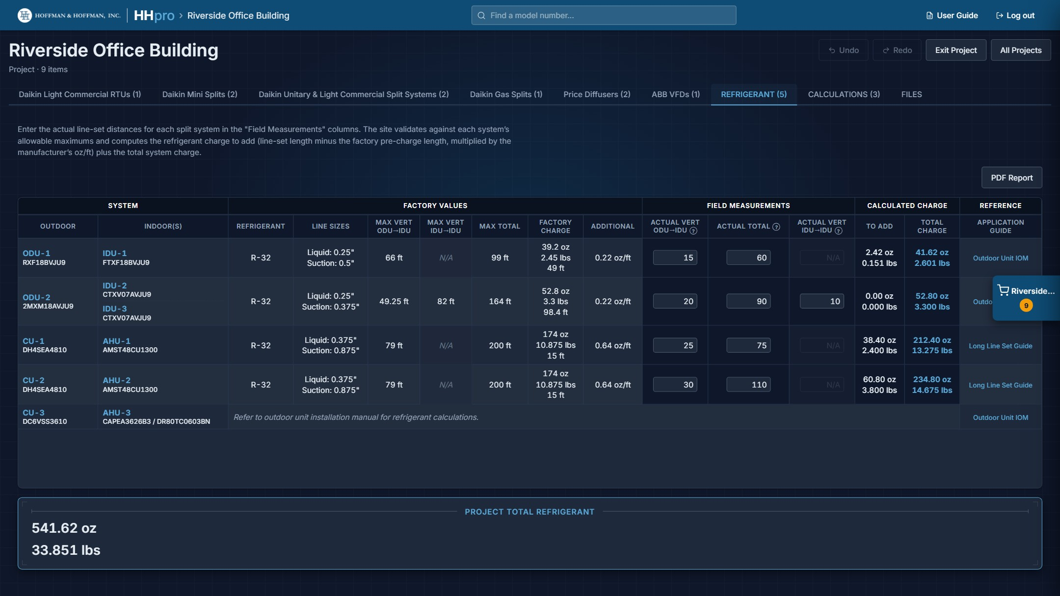
The Refrigerant tab with field measurements entered.
Reading across a row:
- System: the outdoor unit and the indoor unit(s) on it, with the tags you assigned.
- Factory values: refrigerant type, line sizes, the maximum vertical and total lengths the system allows, the factory charge and the length it covers, and the additional charge per foot.
- Field measurements: the boxes you fill in. Enter the actual vertical rise between outdoor and indoor unit and the actual total line length; multi-zone systems also take the vertical separation between indoor units.
- Calculated charge: refrigerant to add (line length beyond the factory pre-charge, times the per-foot figure) and the total system charge.
- Reference: a link to the Outdoor Unit IOM or the Long Line Set Guide for that system.
Anything you enter that exceeds the system's allowable maximum is flagged in the cell as you type. The project total for all systems is shown under the table.
PDF Report produces a print-ready refrigerant report for the whole project, with the same figures laid out for the drawing set. It is also available from the Files tab.
Not every system: Some systems (Gas Splits, for example) publish their charge calculation only in the installation manual. Those rows say so and link to the manual instead of showing boxes.

6. The Calculations Tab
Calculations saved from the calculators (section 9) appear on the project's CALCULATIONS tab, each with its name, when it was saved and a one-line summary.
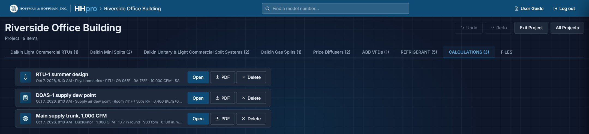
Three saved calculations on the Calculations tab.
- Open: reopens the calculation in its calculator.
- PDF: downloads the calculation's PDF report.
- Delete: removes it from the project.
Saved calculations are also listed under Project Schedules on the Files tab, and go into the ZIP in a CALCULATIONS folder.

7. The Files Tab
The Files tab gathers every document published for everything in the project and packages the ones you want into a single ZIP.
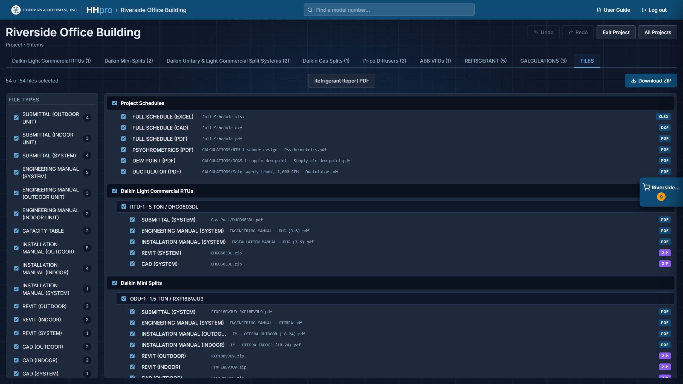
The Files tab: file types on the left, the full tree on the right.

7.1 Choosing what to download
- File types (left panel): every kind of document in the project, with a count (submittals, engineering, installation and operation manuals, capacity tables, Revit families, CAD files and so on). Unchecking a type drops it everywhere at once, which is the quickest way to say "submittals only". Light Commercial RTUs showing Design values add a PERFORMANCE SHEET, the one-page sheet described in section 8.3.
- The tree (right): product, then item, then file. Every level has a checkbox, so you can take everything for one unit, or one document for one unit.
- Everything starts checked. The counter at the top left tracks what you have selected.

7.2 Project Schedules
The first group in the tree is generated rather than downloaded: Full Schedule.xlsx, Full Schedule.dxf and Full Schedule.pdf, each holding every product tab in the project in one file, plus a PDF for each saved calculation. That is the fastest way to get the whole job out at once; the DXF also carries the unit drawings described in section 4.10.

7.3 Downloading
Download ZIP builds the archive and saves it as "<Project Name> - HHpro - <date>.zip", keeping the file names as published. While it works the button shows its progress ("Preparing 12 / 54...", then "Building archive..."); large projects with Revit and CAD content take a moment.
Refrigerant Report PDF, beside the download button, produces the report described in section 5 without leaving the tab.
Missing files: If a document listed in the data has not been published yet, it is skipped and reported in a summary at the end rather than failing the whole download.

8. Design Search
Design Search works the opposite way round from browsing: enter the loads you need to hit and the site returns the equipment that meets them, ranked by how close it comes.

8.1 Running a search
1. Choose a Product category. Every product line except GPS is offered (those your account can see). The form rebuilds itself around that product.
2. Enter your design targets: cooling total and sensible capacity, heating capacity, airflow, and whatever else that product carries. Beside each target is the tolerance you can live with, as a ± percentage (10% to start). Leave a row blank to ignore it.
3. Set any hard constraints under Constraints: size, electrical, efficiency, stages. A result has to match these exactly.
4. Click Find matches. Reset clears the form.
What you can target depends on the product: VFDs are searched on constraints alone, and diffusers and grilles on airflow.
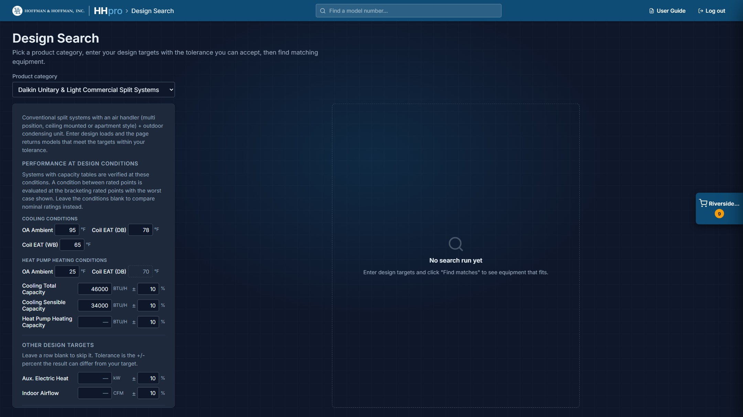
The Unitary & Light Commercial Split Systems form: design conditions on top, then targets and constraints.
Results are sorted by closeness to your targets, with the conditions and targets you searched on shown as chips above the table. Each result carries the same Select, Submittal and Docs buttons as a product page, so a match can go straight into your project.

8.2 Performance at design conditions
For Mini Splits and Unitary & Light Commercial Split Systems the form opens with a Performance at design conditions block: Cooling conditions (OA Ambient, Coil EAT (DB) and Coil EAT (WB)) and Heat pump heating conditions (OA Ambient, with the coil entering air fixed at 70 °F). The capacity targets sit in this block; the other targets are under Other design targets. Fill in the conditions and the search is answered at your condition rather than at the rating point stored in the schedule.
Results then come back in two groups:
- Verified at design conditions: systems whose capacity tables cover your condition. The capacity columns show performance at that condition, and the condition dropdowns stay live on each row so you can compare neighbouring rated points.
- Possible solutions, compared by nominal ratings: systems with no table covering your condition. They were matched against the nominal schedule values, so treat them as candidates to check rather than as verified selections.
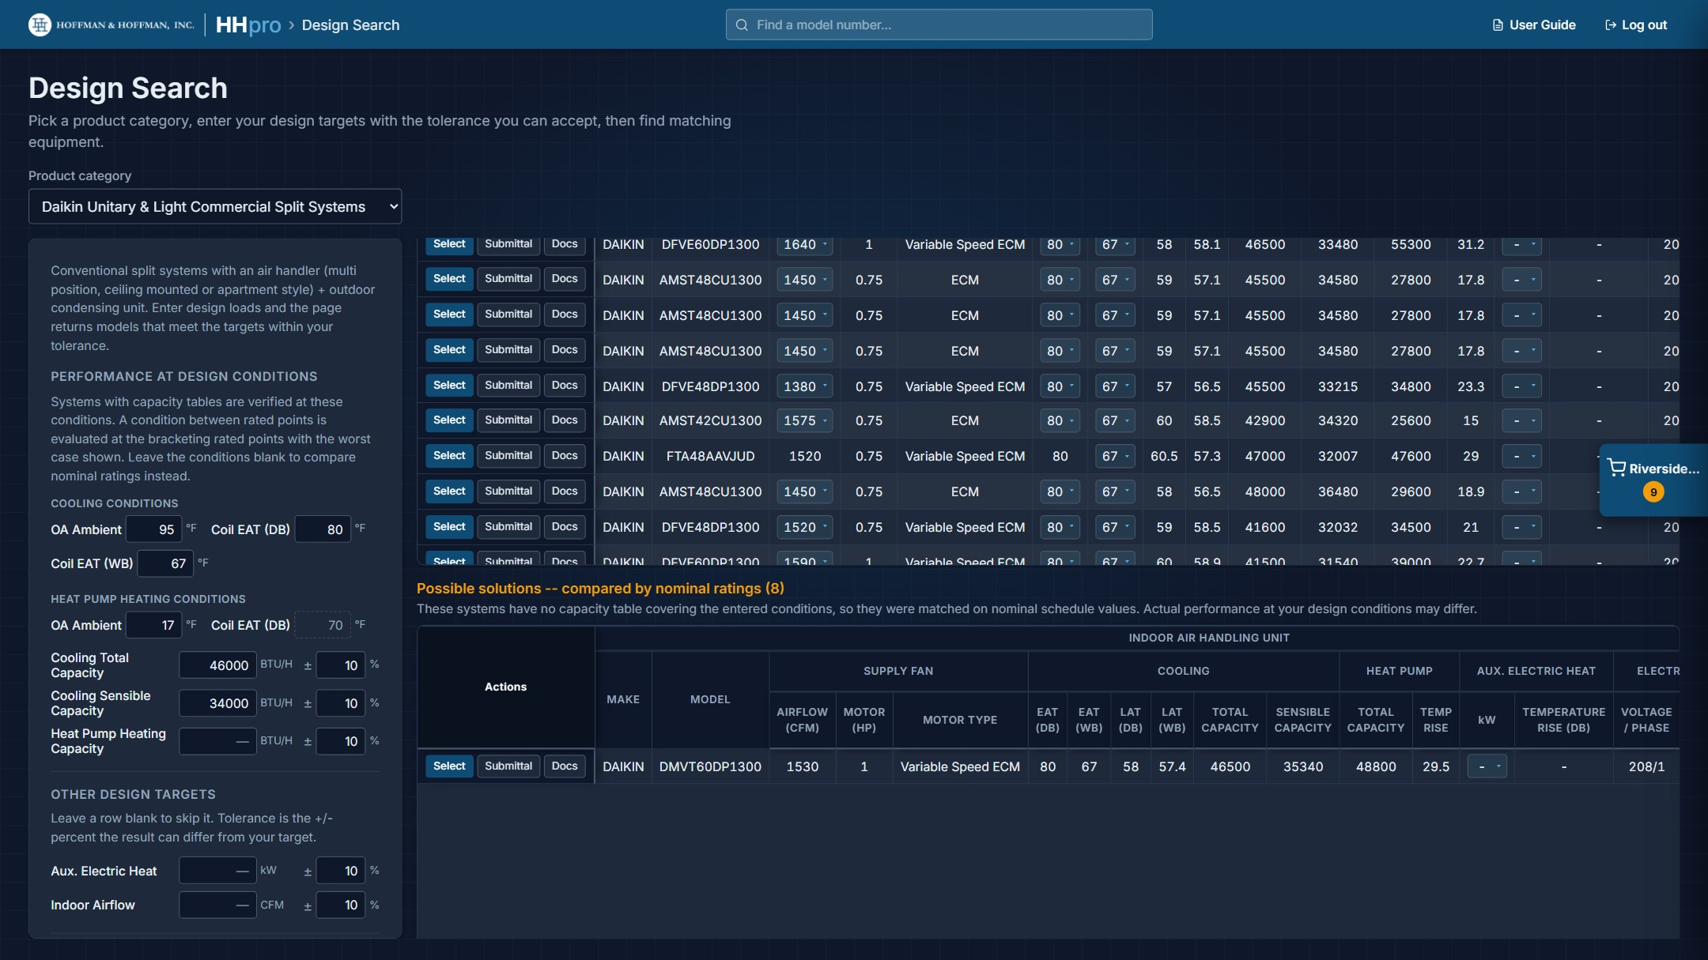
Verified results on top, nominal-only candidates below.
Between rated points: Nothing is interpolated. When a condition falls between two rated points, each result is read at a neighbouring rated point: the next one up for entering air and cooling ambient, and the next one down for heat pump heating ambient. A notice above the results names the points on either side of your condition; use the condition dropdowns on any row to compare the other one. A condition outside a system's table moves that system to Possible solutions. Leave the condition boxes blank to compare nominal ratings instead.

8.3 Daikin Light Commercial RTUs
Light Commercial RTUs get a form of their own, because every number on their schedule came from a selection run at one condition. Here the whole answer is read from Daikin's published capacity tables instead, never from the selections on the schedule, so every number shown is a rated point.
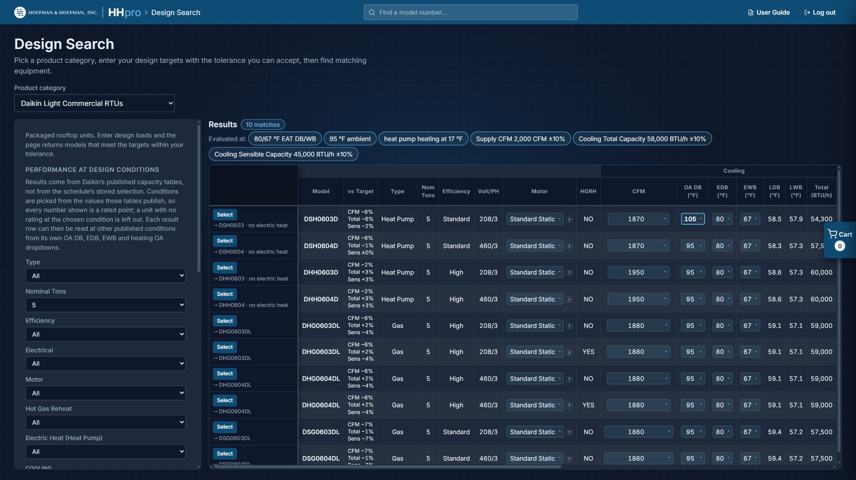
The Light Commercial RTU form on the left; results from the capacity tables, each row with its own Motor, CFM, condition and heat dropdowns and a vs Target column. The first row has been moved to 105 °F OA DB on its own dropdown.
- Constrain the cabinet first if you need to: Type (All, Gas or Heat Pump), Nominal Tons, Efficiency (Standard, High or Variable Speed), Electrical, Motor (the motor each result row starts on; every row can switch it), Hot Gas Reheat (shown when a unit that offers it is in scope) and Electric Heat (Heat Pump).
- Choose the conditions: Outdoor Ambient DB, Cooling EAT DB and Cooling EAT WB, and Heating Outdoor Ambient DB for heat pumps. These are dropdowns of the values Daikin publishes for the units in scope; values that only some models publish are marked, for example "(DVH only)". The defaults are 95 °F ambient, 80/67 °F entering air and 17 °F for heating. Each result row can then be read at other conditions of its own (Conditions on the row, below).
- Enter targets for Supply CFM, Cooling Total Capacity, Cooling Sensible Capacity, Gas Heating High Stage Temp Rise (gas units) and Heat Pump Heating Capacity (heat pumps). Above them, choose how they are judged: Within ± tolerance, where each is met inside its own ± percentage, or Meet or exceed (smallest first), where each capacity is a minimum, the closest fit is listed first, and the box beside it becomes a cap on how far above the target a unit may be (blank = no limit). Supply CFM is always ± tolerance.
- Heat pumps also take a Heating Load (heat pump + electric heat): the heat pump's capacity at the heating outdoor temperature plus its electric heat kit (kW × 3,412 BTU/h) has to cover it. It is always a minimum, so it has no tolerance.
- Tick Power Exhaust under Electrical options if the units need it. It applies to every result and changes MCA and MOP.
Results show one row per unit with the full cooling, gas heating and heat pump heating picture at your condition. On the row you pick the gas heat size or electric heat kit and the Motor (Standard Static or High Static); the model number, MCA, MOP and motor HP follow at once, without a new search. When you entered targets, a vs Target column shows how far the unit is over or under each one, for example "Total +2%, Sens +5%"; a figure outside its target is highlighted. Units that could not be evaluated at your condition are named under the table with the reason, so you know nothing was silently dropped.
Each unit is read at every airflow Daikin publishes for it, and the CFM column is a dropdown of those airflows. It opens on the nominal airflow, or on the one nearest the Supply CFM you entered; pick another and cooling, leaving air, gas heat leaving temperature and DVH heating are read again. Airflows the unit is not rated at, and gas heat sizes whose temperature rise would fall outside Daikin's range, are greyed out. An airflow that misses one of your targets is marked "(off target)" but can still be picked.
Heat pump heating shows the airflow it is published at. DSH and DHH units publish heating at their nominal airflow only, so it stays at that CFM whichever cooling airflow you pick; DVH heating follows the dropdown.
Conditions on the row: the OA DB, EDB, EWB and heat pump heating OA columns are dropdowns too, starting at the form's conditions. Pick another and only that row is read again, keeping its heat size or kit, CFM and motor. Only values Daikin publishes for the unit are listed, and ones not rated with the row's other conditions are greyed out "(not rated)"; EWB follows EDB, and DVH heating shows its wet bulb, for example "17 (15 WB)". A changed value is bold and outlined (hover the row for details; pick the search's value to go back). The row stays listed even if it misses a target, flagged in vs Target, and kits too small for a Heating Load can be picked but are marked "(short)". Select and Replace take the row's conditions with them; Find matches resets every row to the form's.
Heat kits: with a Heating Load, each heat pump opens on the smallest kit that covers it, and the HP + Kit column shows the heat pump and kit together. Kits too small for the load are listed but greyed out "(short)". A kit outside Daikin's electric heat airflow limits at the row's CFM is marked "(airflow)" and its cell is outlined; pick a higher CFM or another kit. The sizing uses each kit's rated kW with no voltage correction, so check a 208 V unit's kit output against Daikin's electric heat data.
Select on a result opens the Light Commercial RTU schedule at that unit, showing its design-condition values. The row is marked with a Design values button (click it to switch to Standard values and back), and a banner explains where the numbers came from. Reset all to standard puts every row back. A heat pump's heating cell reads, for example, "51000 (17°F OA, 3000 CFM, COP 2.25)", and its 47 °F and 17 °F rating columns show "-" (those are AHRI ratings, not catalog values). ESP and the gas heating entering air stay as scheduled.
Select the row there to add it to your project. A unit added while showing Design values keeps them on the project schedule and in the Excel, CAD and PDF exports, and they are saved with the project; one added showing Standard values keeps the selection run in Daikin's software. When every heat pump on a schedule came from Design Search, the 47 °F and 17 °F rating columns are left off. On the project schedule a Design Search unit's heat kit or gas heat size is fixed; use Configure on its row to change it (section 4.5).
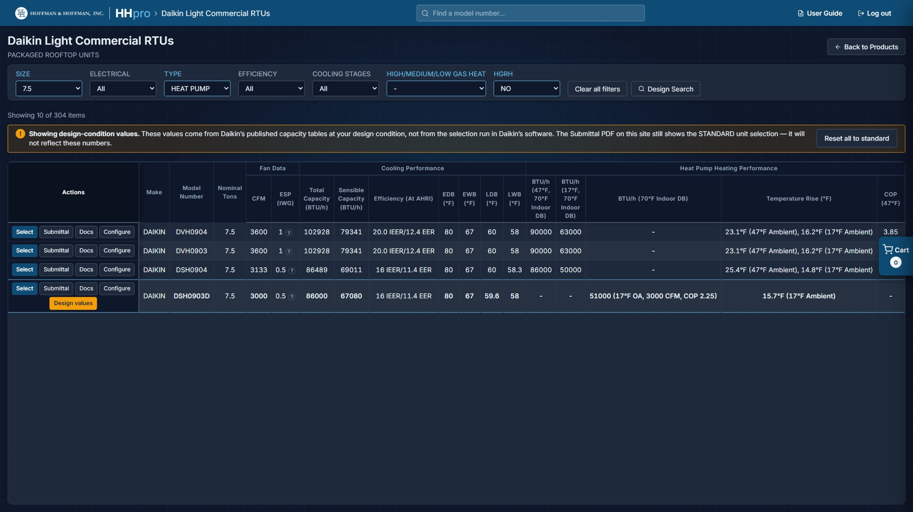
A heat pump selected from Design Search: catalog values, with its 47/17 °F rating columns blank.
Design values: The submittal PDF still documents the standard unit selection. A one-page "Performance at design conditions" sheet with the design values opens beside it from Submittal, is listed first under Docs (on the product page and the project schedule) and goes in the Files tab ZIP. The fan is not checked, so confirm with Daikin's fan data that the motor delivers the airflow at your static pressure. The project CSV export does not carry design values.
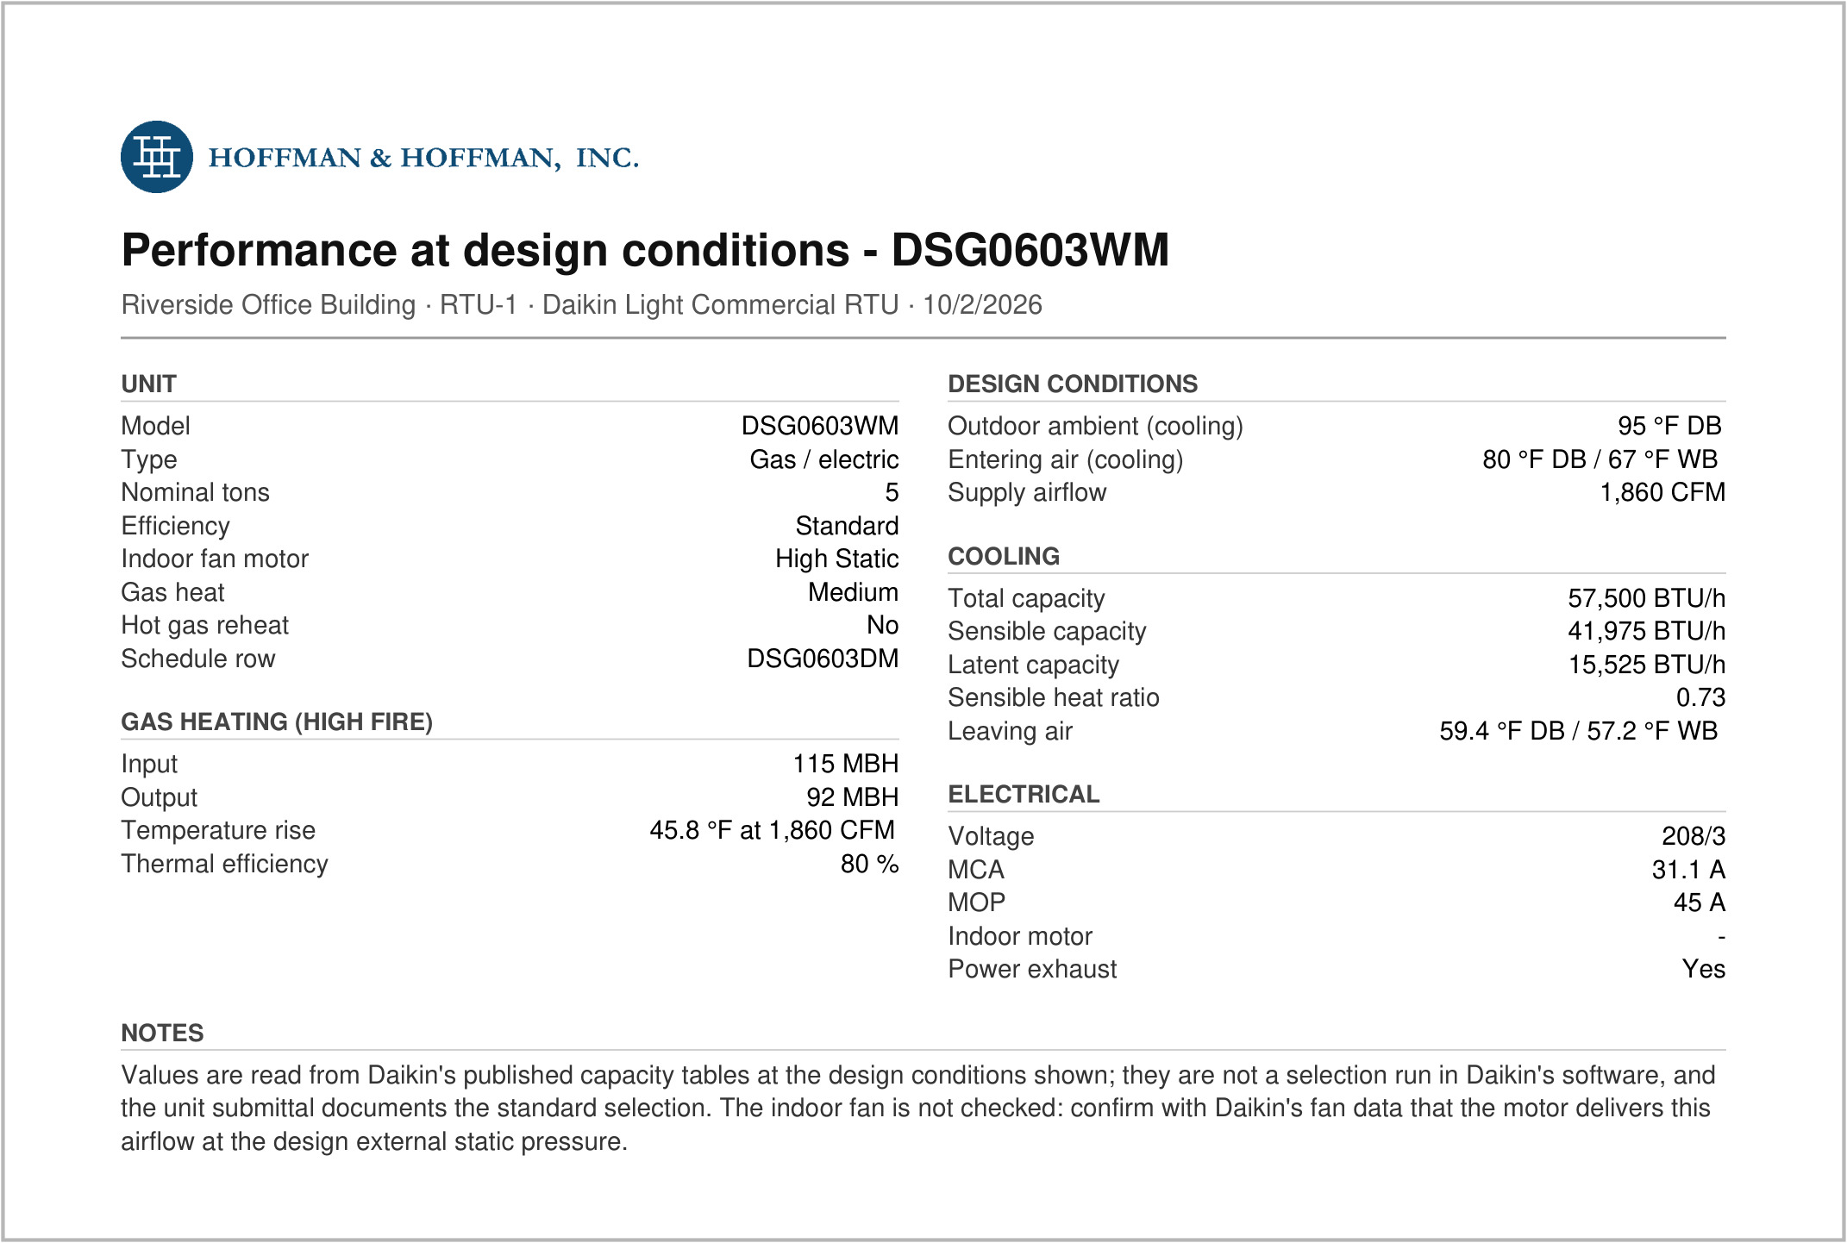
The performance sheet for a gas unit on design values: conditions, capacities, motor, power exhaust and MCA / MOP.

Configuring a unit from the schedule
The Configure button on a Light Commercial RTU row (section 2.5) opens this form already narrowed to that unit: Type, Nominal Tons, Efficiency, Electrical and Hot Gas Reheat are filled in to match it, and the search runs straight away. A banner names the unit. The result opens on the row's gas heat size or electric heat kit and its motor, at the published airflow nearest the row's CFM that the unit can run at.
Change the motor, CFM or conditions on the result row, or change power exhaust, hot gas reheat or the design conditions in the form and click Find matches again; the unit stays in view with the heat size or kit, CFM and motor you picked on its row. Select puts it back on its schedule row showing Design values, as above. Clicking Configure on a row that is already showing Design values reopens that configuration. Change Type, Nominal Tons or Efficiency, or click Reset, to search every unit again.
From a project schedule, Configure works the same way, but every result's button reads Replace: it swaps the unit on the project schedule and keeps its tag and place (section 4.5).
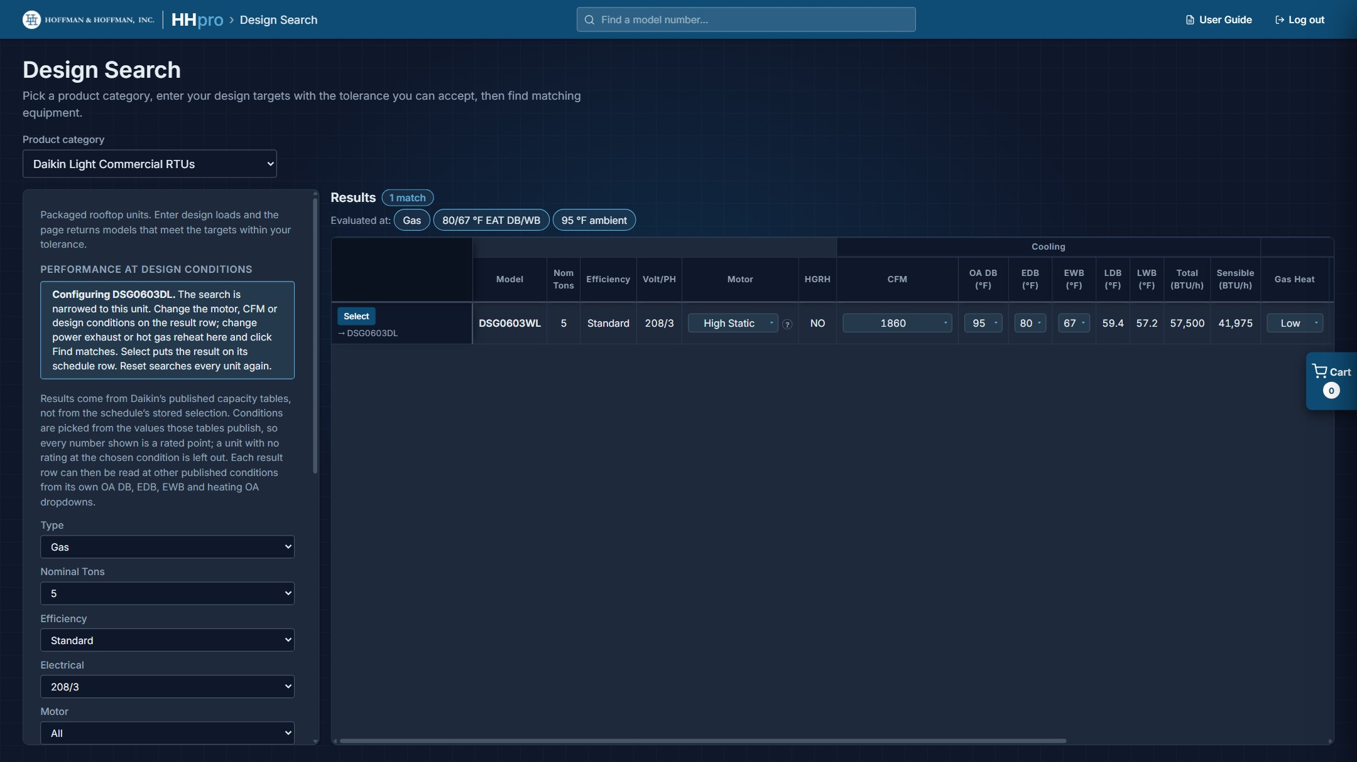
Configure on DSG0603DL, with the result row's Motor switched to High Static.

9. Calculators
The Calculators tile opens a page with three calculators: Psychrometrics, Supply air dew point and Ductulator. The breadcrumb (Calculators › name) takes you back to the list.

9.1 Common controls
- Altitude: site elevation in feet. The barometric pressure beside it follows. In Psychrometrics, Look Up Climate Conditions fills it in from a weather station (section 9.2).
- IP / SI: switch units.
- Save to project: saves the calculation, under a name you choose, to the active project (section 9.5).
- Export PDF: downloads a PDF report of the calculation.
- The ? icons explain each input.

9.2 Psychrometrics
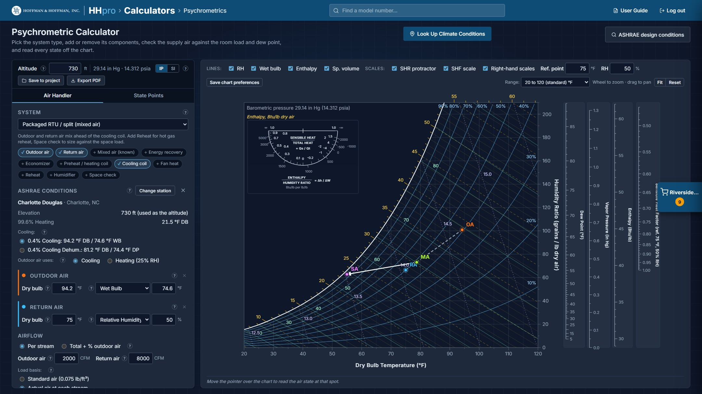
The Psychrometric Calculator with a packaged RTU (mixed air) system, using the Charlotte Douglas design conditions.
The Psychrometric Calculator builds an air-handling process on a live psychrometric chart.
- Air Handler tab: pick a System type (Packaged RTU / split (mixed air), Packaged RTU / split (mixed air known), 100% outdoor air / DOAS, Makeup air / heating, Winter humidification, or Custom), then add or remove components with the chips: Outdoor air, Return air, Mixed air (known), Energy recovery, Economizer, Preheat / heating coil, Cooling coil, Fan heat, Reheat, Humidifier and Space check.
- State Points tab: plot independent air states.
- The results list every state point and the load of each stage, with condensate and drain size; the chart shows every state and process line. Chart options above it turn on the RH, wet bulb, enthalpy and specific volume lines and the optional SHR protractor, SHF scale and right-hand scales. Scroll to zoom, drag to pan, and use Fit or Reset to get back.
- Look Up Climate Conditions brings a weather station's ASHRAE design conditions into the calculator (below).
- ASHRAE design conditions opens the ASHRAE climatic design conditions site in a new tab, for stations outside the United States or data the lookup does not carry.
- The PDF carries the chart, the results, and an appendix of definitions and worked formulas.
The HHpro Psychrometrics Guide covers the chart and every component in detail.

Looking up climate conditions
Look Up Climate Conditions, at the top of the page, opens a map of North America with every weather station in the 2025 ASHRAE climatic design conditions (IP): 2,441 stations across the 50 states.
- Drag the map to move around and use the mouse wheel to zoom. The +, − and home buttons do the same; home goes back to the contiguous US.
- Right-click near the site (press and hold on a touch screen) to list the 10 closest stations, nearest first, with their distance. They are numbered on the map in the same order.
- Or type a city, station or state in the search box.
- Click a station in the list or on the map to see its elevation and design conditions: the 99.6% heating dry bulb, the 0.4% cooling dry bulb with its wet bulb, and the 0.4% dehumidification dew point with its dry bulb.
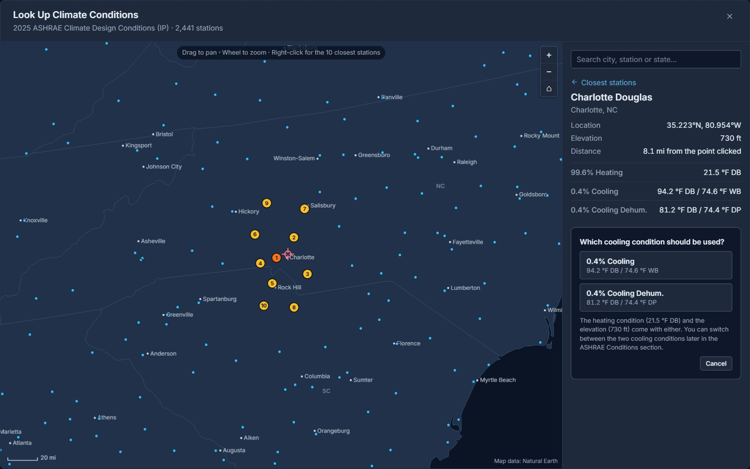
Right-click near Charlotte, NC: the 10 closest stations, with Charlotte Douglas open and the cooling question showing.
Import to psychrometric chart asks which cooling condition to use: 0.4% Cooling (the peak dry bulb with its wet bulb) or 0.4% Cooling Dehum. (the peak dew point with its dry bulb, usually the one that governs dehumidification and DOAS). Then:
- The Altitude is set to the station's elevation.
- An ASHRAE Conditions section appears under System with the station's data. Its Cooling choice switches between the two cooling conditions at any time.
- Outdoor air is filled in to suit the system: the cooling condition when it has a cooling coil, or the 99.6% heating dry bulb at 25% RH when it only heats (preheat / heating coil or humidifier). Outdoor air uses switches between the two, for example on a unit with both a heating and a cooling coil.
- Changing the system type or its components fills Outdoor air in again. Numbers you type into Outdoor air stay until then.
- Change station reopens the map on the current station. The × clears the station; Outdoor air and Altitude keep their values.
- The station is saved with the calculation and listed at the top of the PDF.

9.3 Supply Air Dew Point
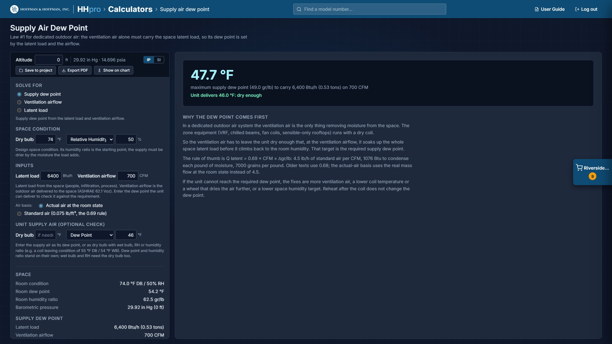
Supply Air Dew Point with a supply condition checked against the requirement.
For dedicated outdoor air systems the ventilation air alone must carry the space latent load, so its dew point is set by the latent load and the airflow.
- Solve for: Supply dew point, Ventilation airflow or Latent load.
- Enter the Space condition and the Inputs (latent load and ventilation airflow), and choose the air basis: actual air at the room state, or standard air (the 0.69 rule).
- Unit supply air (optional check): enter the dew point the unit delivers (or its dry bulb with wet bulb, RH or humidity ratio) and the result says whether it meets the requirement.
- Show on chart opens Psychrometrics with a DOAS system and a Space check already filled in.

9.4 Ductulator
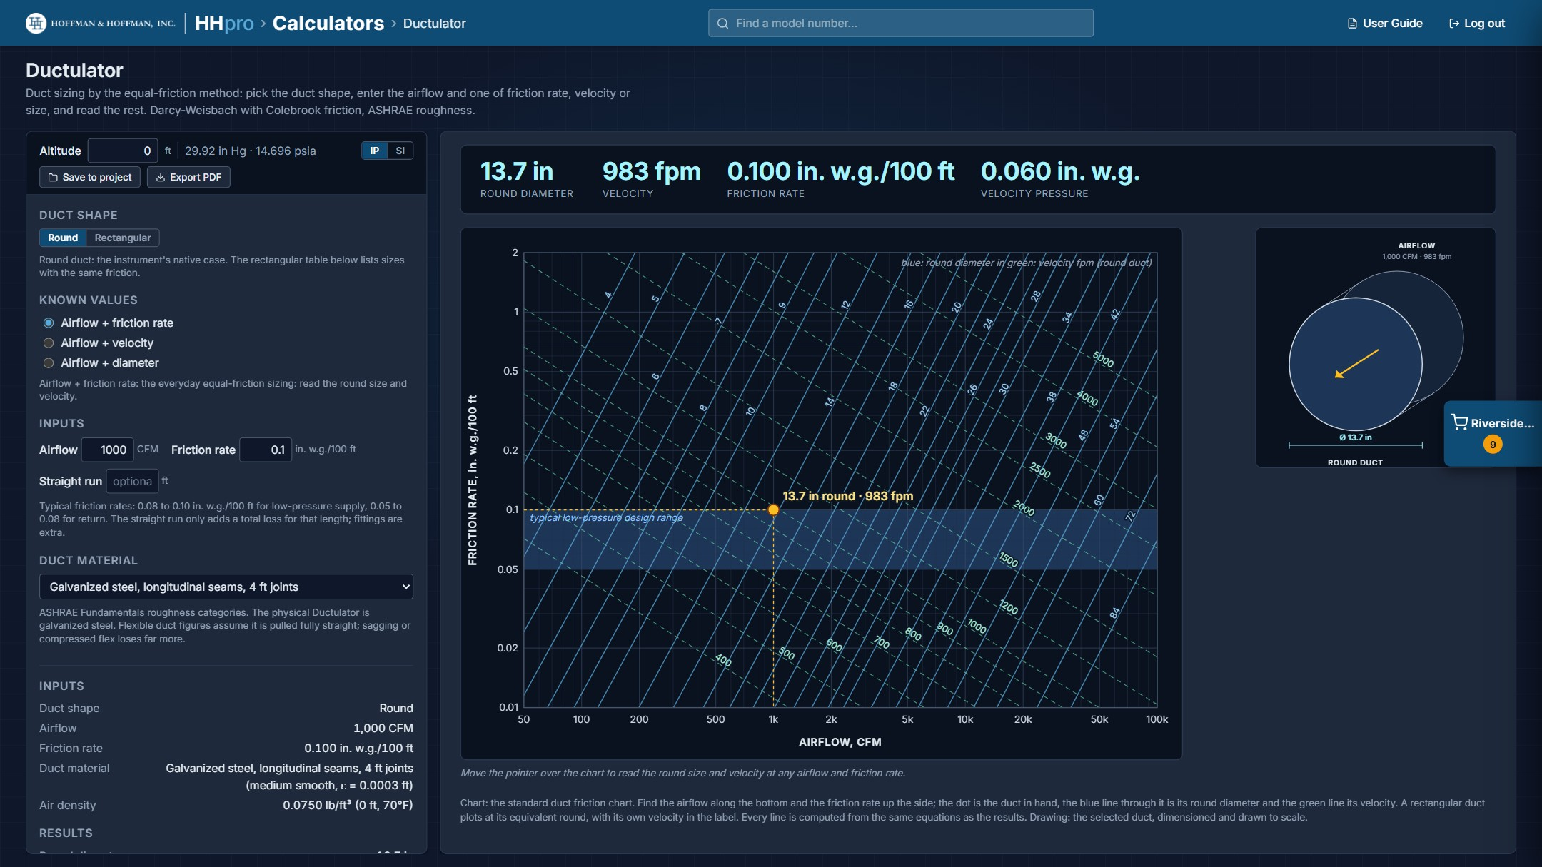
The Ductulator sizing a round duct on the duct friction chart.
Duct sizing by the equal-friction method, using Darcy-Weisbach with Colebrook friction and ASHRAE roughness.
- Duct shape: Round or Rectangular.
- Known values: airflow plus friction rate, velocity or size. The optional Straight run adds the total loss for that length (fittings are extra).
- Duct material: nine ASHRAE roughness categories, from galvanized steel to flexible duct.
- Results: size, velocity, friction rate and velocity pressure, with the nearest stock size and a table of rectangular sizes with the same friction. The duct is plotted on the duct friction chart and drawn to scale beside it.

9.5 Saving calculations to a project
Click Save to project, type a name (the box suggests one) and click Save. The calculation is saved to the active project; if no project is active, HHpro asks where it should go, just like the first Select (section 3.1). Saved calculations appear on the project's CALCULATIONS tab (section 6) and in the Files tab ZIP.

10. Finding a Model Number
The search box in the header searches every product your account can see. Type all or part of a model number; the dropdown shows up to ten matches with the product each belongs to, and highlights the part you typed. Use the arrow keys and Enter, or click a result.
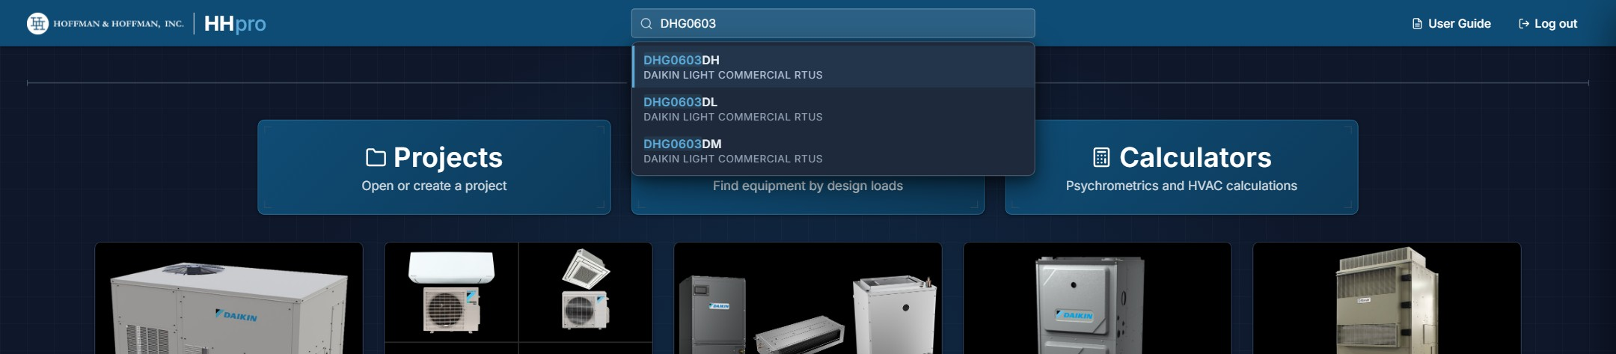
Searching for a model number from the header.
The site opens that product's page with the schedule already narrowed to the model, shown as a chip (Model contains "...") under the filters. Clear on the chip drops back to the full list; the normal filters work alongside it.
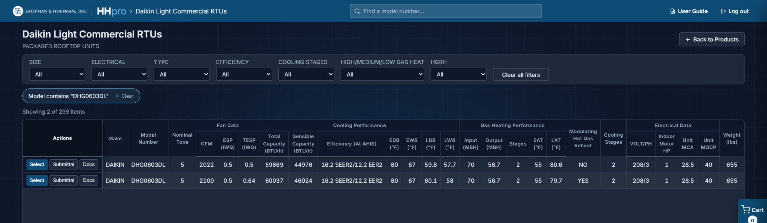
The product page opens filtered to the model you picked.
The first search after the page loads takes a few seconds while the index is built across every product; after that it is instant.

11. Appendix

11.1 Privacy and your data
HHpro accounts and saved projects are held on a server run by Hoffman & Hoffman. The site has no advertising, no analytics and no third-party scripts, and it sends no email itself.
- What is stored: your name, company, office location(s), user level and email address (entered by the administrator who set up your account), a scrambled form of your password, and the projects you save.
- Cookies: one cookie keeps you signed in. There are no advertising, analytics or third-party cookies.
- Sharing: your information is not sold or shared with anyone outside Hoffman & Hoffman. The site is delivered through Cloudflare, which handles the network connection under its own privacy policy.
- How long: for as long as your account is active. Deleted accounts and deleted projects are removed within 30 days.
- Your choices: to see, correct or delete the information held about you, email eric.creel@hoffman-hoffman.com.
The Privacy & Data link at the bottom of the overview and the sign-in page has the full notice.
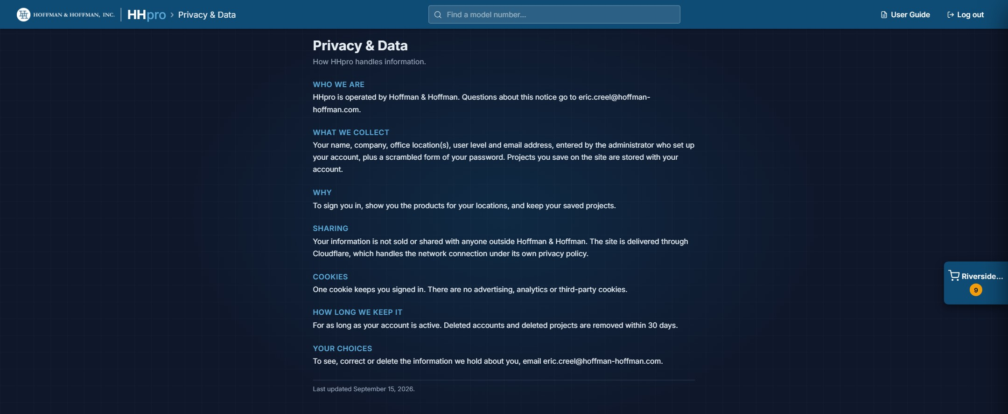
The Privacy & Data page.

11.2 Quick reference
- Build a schedule: product tile → filter → Select the systems you need → cart → View Project → Auto Tag → Add / Remove Columns → Excel / CAD / PDF.
- Find a unit by load: Design Search → category → conditions and targets → Find matches → Select.
- Find the smallest unit that covers a load: Design Search → Light Commercial RTUs → Meet or exceed → targets → Find matches.
- Size a heat pump's electric heat: Design Search → Light Commercial RTUs → Heat Pump → Heating Load → Find matches; each unit opens on the smallest kit that covers it.
- Change a rooftop unit's options: Light Commercial RTU schedule → Configure → motor, power exhaust or conditions → Select. On a project schedule: Configure → Replace.
- Compare a rooftop unit at another condition: Design Search → Light Commercial RTUs → Find matches → change OA DB, EDB, EWB or heating OA on that result row.
- Find a unit by model: type it in the header search box and click the result.
- Run a calculation: Calculators → pick one → Save to project or Export PDF.
- Use a site's design weather: Calculators → Psychrometrics → Look Up Climate Conditions → right-click near the site → pick a station → Import to psychrometric chart.
- Get the paperwork: project view → FILES → untick what you do not need → Download ZIP.
- Size the refrigerant charge: project view → REFRIGERANT → enter line-set lengths → PDF Report.
- Keep a copy outside HHpro: Projects → Export All to CSV.
- Reset your password: sign-in page → Forgot password? → Open email → send it.

11.3 Things to watch for
- Projects save to your account automatically. If you see "Can't reach the HHpro server to save", keep the tab open until "Back in touch with the server" appears.
- A temporary cart is never saved. Create a project for anything you want to keep.
- The Grille schedule only draws the first 500 matching rows; narrow the filters to see the rest.
- Cells you edit by hand stay as you typed them, are not recalculated afterwards, and are tied to their place in the schedule. Make hand edits last.
- In Design Search, "Possible solutions" were matched on nominal ratings, not verified against a capacity table at your condition.
- Light Commercial RTUs selected from Design Search show Daikin's catalog values, not the selection run in Daikin's software. The submittal PDF still shows the standard selection (their performance sheet shows the design values), the fan is not checked at the airflow picked, and the project CSV export does not keep the design values.
- Heating Load sizing uses each electric heat kit's rated kW. Check the kit's output on a 208 V unit against Daikin's electric heat data.
- The ASHRAE heating condition is a dry bulb only, so Look Up Climate Conditions gives the outdoor air 25% RH with it. Enter the real winter humidity in Outdoor air before sizing a humidifier.
- For split systems, one selection covers the outdoor unit and its indoor units; you do not select them separately.
- Submittals, documents, PDF exports and the refrigerant report open in new tabs or windows; allow pop-ups for hhpro-hvac.com.

11.4 Getting help
If something looks wrong (a capacity, a document that will not open, a model that should be there and is not), contact Eric Creel at eric.creel@hoffman-hoffman.com. For account questions such as access, office locations or a new password link, contact the person who set up your account.

